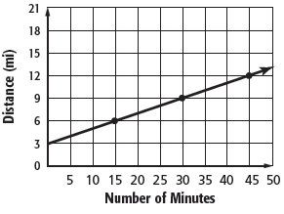

**29.**

**28.**

**D.**

**B.** **−**

**C.**

**A. −**

**29.** What is the slope of the line that passes through the points *C*(–2, 4) and *D*(1, –1)?

**27.**

**26.**

**24.**

**25.**

**I.** −

**H.** −

**G.**

**F.**

**24.** What is the constant rate of change between *x* and *y* in the table below?

|  |  |  |  |  |
| --- | --- | --- | --- | --- |
| ***x*** | −3 | −1 | 1 | 3 |
| ***y*** | 7 | 4 | 1 | −2 |

**23.**

**D.** Miguel traveled 5 miles per minute.

**C.** Miguel traveled 0.2 mile per minute.

**B.** Molly’s speed was greater than Miguel’s speed.

1. Molly’s speed was the same as Miguel’s speed.

**23.** Miguel and Molly are cyclists. The graph shows the distance Miguel biked one day. Molly biked at a rate of 0.15 mile per minute. Which statement about their speeds is true?

**Section 3: *Functions***

–2

***f*(*x*)**

***x***

7

5

3

1

**A.** *f*(*x*) = *x* + 3

**B.** *f*(*x*) = 2*x*

**C.** *f*(*x*) = 4*x* – 1

**D.** *f*(*x*) = *x* + 2

**27.** Which function matches the function table at the right?

**I.** quadratic

**H.** qualitative

**G.** nonlinear

**F.** linear

**28.** Graphs that represent situations that may not have numerical

values are called?

0

***x***

15

7

3

1

***y***

10

5

0

–5

***x***

0

–2

–4

–6

***y***

17

13

9

5

***x***

13

9

5

1

***y***

0

2

4

6

***x***

**D.**

**B.**

**C.**

**A.**

**25.** Which table represents a nonlinear function?

11

9

7

5

***y***

2

1

0

–1

***x***

***y***

***O***

**26.** Which function is graphed at the right?

**G.** *y* = *x* + 2

**I.** *y* = –2*x* + 2

**H.** *y* = $-\frac{1}{2}x$ + 2

**F.** *y* = $\frac{1}{2}x$ + 2

SCORE

PERIOD

NAME DATE

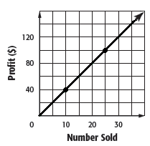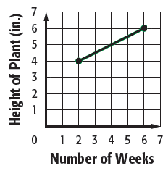

**H.** *y* = 3x – 14

**I.** *y* = 3x + 10

**F.**  *y* = 3x + 10

**G.** y = 3x – 2

**36.**

**36.** Which equation, in slope-intercept form, passes through (–2, 4) and has a slope of 3?

**Page 4**

**C.** the cost per guest

**D.** Alice’s age

**A.** the number of guests

**B.** the cost to rent the game center

**35.**

**35.**  Alice is having her birthday party at a game center. The center charges $100 plus $20 per guest. The total cost of the party *y* can be represented by the equation *y* = 20*x* + 100. What does the *y-*intercept represent?

**34.**

***y***

1

***O***

1

***x***

**H.** *y* = 2*x* – 1

**I.** *y* = 2*x* + 1

**F.** *y* = –2*x* – 1

**G.** *y* = –2*x* + 1

**34.** What is the equation in slope-intercept form for the graph of the line shown?

**33.**

**C.** *t* = 9.5*c*

**D.** *c* = 9.5*t*

**A.** *t* = 6.5*c*

**B.** *c* = 6.5*t*

**33.** Student tickets cost $6.50 each, and adult tickets cost $9.50 each. Which equation can be used to find the total cost *c* of any number of student tickets *t*?

**32.**

**F.** slope: 9, *y*-intercept: – 6

**G.** slope: – 6, *y*-intercept: 9

**H.** slope: –9, *y*-intercept: –6

**I.** slope: –6, *y*-intercept: –9

**D.** Store B made a profit of $4 per T-shirt.

**32.** What are the slope and *y*-intercept for the graph of *y* + 9*x* = –6?

**31.**

**C.** Store A made a profit of $3.50 per T-shirt.

**B.** Store B made a greater profit per T-shirt.

**A.** Store A made a greater profit per T-shirt.

**31** The profits from selling T-shirts at store A are shown in the graph. The profit *y* for selling *x* T-shirts at store B is represented by the equation *y* = 3.75*x.* Which of the following statements is true?

**I.** The initial height of the plant was 4 inches.

**H.** The initial height of the plant was 2 inches.

**G.** The plant grew 0.5 inch per week.

**F.** The plant grew 2 inches per week.

**30.** A plant is a certain height. The height of the plant is measured for several weeks. The graph shows the height of the plant for each week. Which statement is true?

**30.**

SCORE

PERIOD

NAME DATE

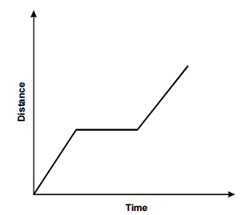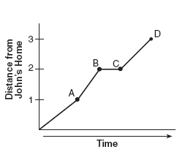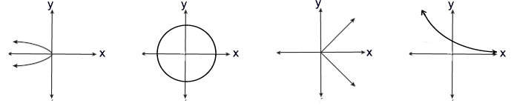 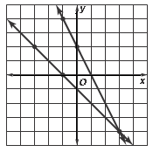

**42.**

**41.**

**42.** Students in a class are making qualitative graphs of their motion as they move along a straight line. Which of the following statements best describes the motion represented in the distance versus time graph to the right?

1. The student accelerated to a certain speed, walked at that speed for a period of time and then started accelerating again.
2. The student started walking at a constant speed, then stopped for a while before continuing at approximately the same speed.
3. The student walked along a straight line, turned right, continued walking in a straight line, turned left and then continued walking in a straight line.
4. The student started speeding up, stopped for a period of time and then resumed walking at a faster and faster speed.

**41.** John left him home and walked 3 blocks to his school as shown in the accompanying graph. What is one possible interpretation of the section of the graph from point *B* to point *C*?

1. John arrived at school and stayed throughout the day.
2. John waited before crossing a busy street.
3. John returned home to get his math homework.
4. John reached the top of a hill and began walking on ground level.

**40.**

**F. G. H. I**

**40.** Which graph represents a function?

**39.**

**D.** (2, 6)

**C.** (–2, 6)

**B.** (–2, –6)

**A.** (2, –6)

**39.** What is the solution of the system of equations?

*y* = *x*  

4x – *y* = 2

(1, –3)

**I.**

**H.** (1, 3)

**G.** (–3, 1)

**F.** (3, –1)

**38.**

**38.** What is the solution of the system of equations?

*y* = *x* + 2

*y* = 3*x*

**37.**

**C.** (3, 4)

**D.** (3, –4)

**A.** (3, 4)

**B.** (–3, 4)

**37.** Which of the following is the solution of the system of equations shown?

**Section 4: *Short Answer and Extended Response***

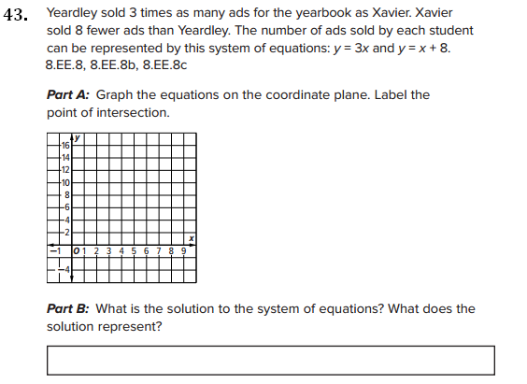

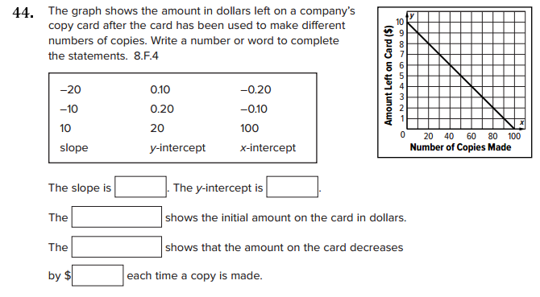

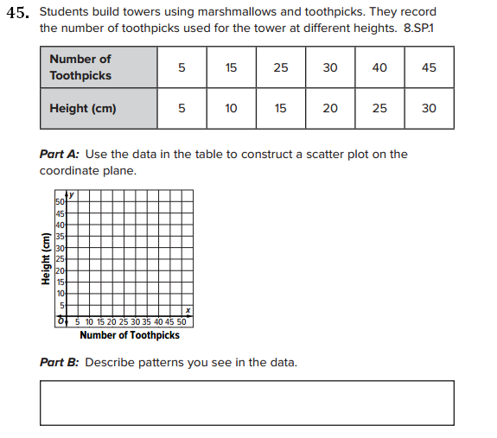

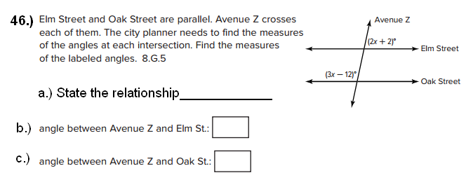

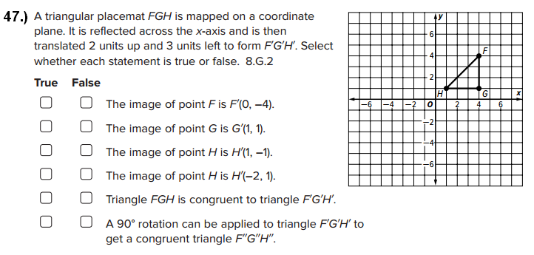

**48.)** Volume of a cone:  ***Show all work***

