Slope Homework Practice

Find the slope of each line from the graph
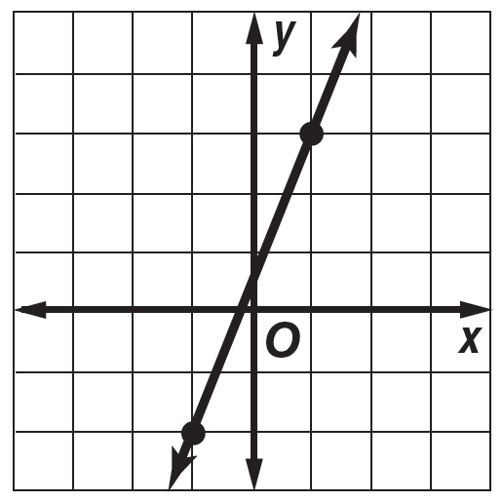
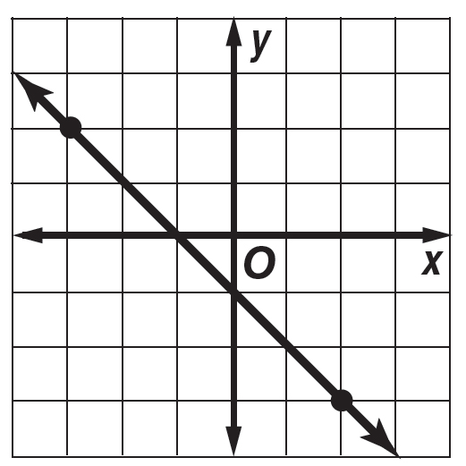
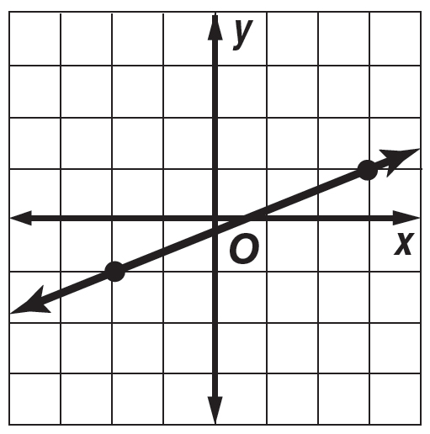
1. 2. 3.

Find the slope of the line that passes through each pair of points. (Using the slope formula)

4. A(1, 3), B(4, 7) 5. C(3, 5), D(2, 6) 6. E(4, 0), F(5, 5)

