Homework Practice

Slope and Similar Triangles

Graph each pair of similar triangles. Then write a proportion comparing the rise to the run for each of the similar slope triangles and find the numeric value. (Slope)

1. ∆EFG with vertices E(1,9), F(1,5), and G(2,5); ∆GHI with vertices G(2,5), H(1,2), and I(3,1)
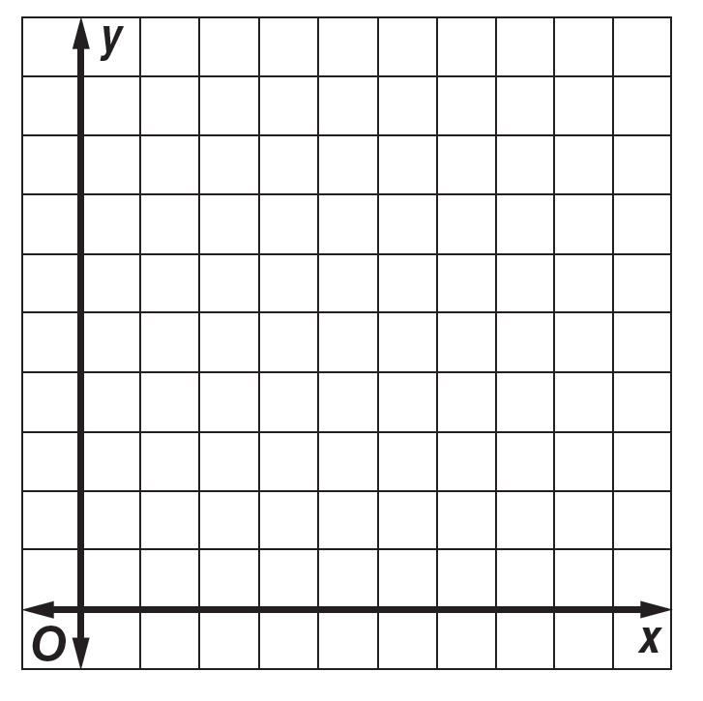

3. ∆RST with vertices R(1,6), S(1,–6), and T(–3,–6); ∆UVW with vertices U(–1,0), V(–1,–3), and
W(–2,–3)

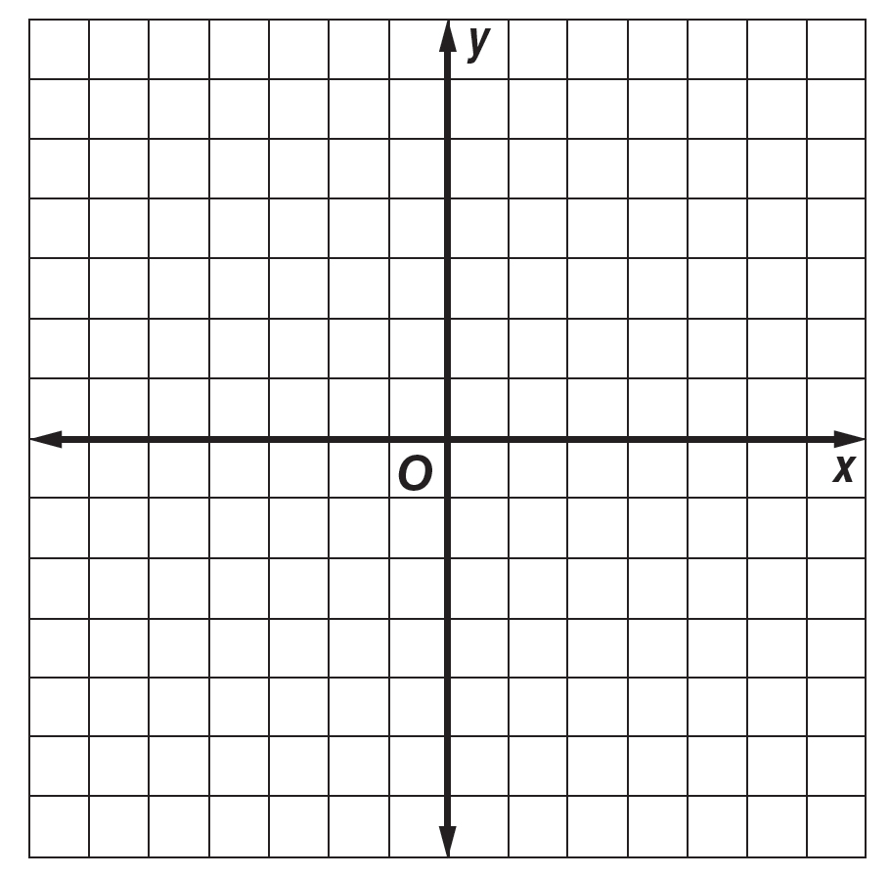

2. ∆JNL with vertices J(–3,3), N(–3,–3), and L(5,–3); ∆KML with vertices K(1,0), M(1,–3), and L(5,–3)
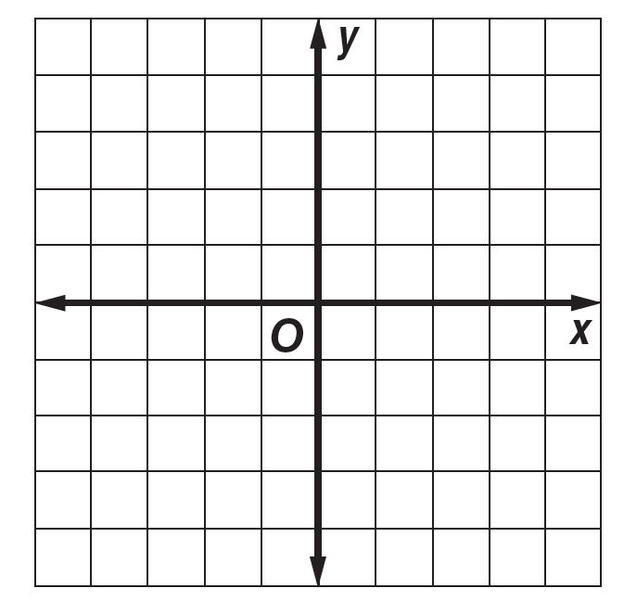

4. ∆DEF with vertices D(–6,5), E(–6,2), and F(–2,2); ∆FMW with vertices F(–2,2), M(–2,–4), and
W(6,–4)

