Real-Life Quadratic Functions Homework

GEOMETRY For Exercises 1–3, use the following information.

The quadratic equation $A = {6x}^{2}$ models the area of a triangle with base 3x and height 4x.

1. Graph the equation. Explain why you only need to graph the function in the upper right quadrant.  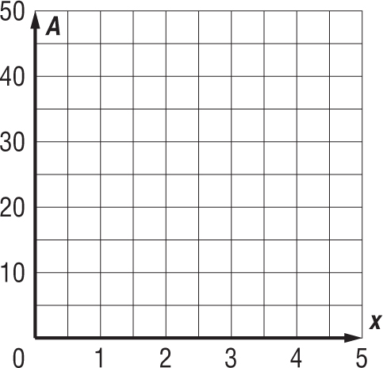 | 2. Explain how to find the area of the triangle when x = 3 inches. Then find the area.
3. Explain how to use your graph to determine the value of x when the area is 24 square inches. Then find the base and height of the triangle when its area is 24 square inches. | 4. PHYSICS The quadratic equation $K = {500s}^{2}$ models the kinetic energy in joules of a 1,000-kilogram car moving at a speed of s meters per second. Graph this function. Then use your graph to estimate the kinetic energy at a speed of 8 meters per second.  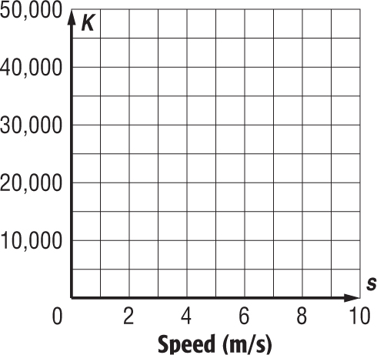
5. CARS The quadratic equation $d=\frac{s^{2}}{20}$ models the stopping distance in feet of a car moving at a speed of s feet per second. Graph this function. Then use your graph to estimate the stopping distance at a speed of 40 feet per second.
