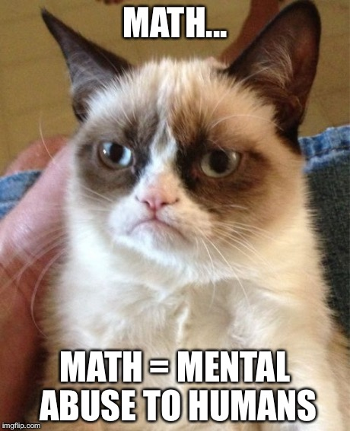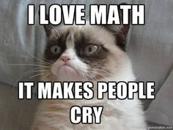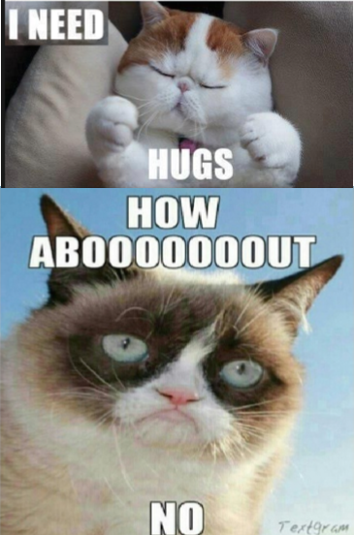
INTRODUCTION: Grumpy Cat is very grumpy all the time. He enjoys casting a dark cloud over happy situations and sees the glass as half empty. His favorite word is “NO,” and has also been called a “No-It-All.” One of the only things that Grumpy Cat enjoys is Mathematics because it makes people cry.
YOUR MISSION: To make Grumpy Cat happy by doing Mathematics incorrectly (common misconceptions).
YOUR TASK: Grumpy cat has posted 5 really difficult multi-step equations with fractions and decimals since it makes him happy if you do the mathematics incorrectly. Since we don’t want to upset grumpy cat we have to solve the really difficult equation two different ways so we can ensure that it is correct, then you have to pretend that you are solving it wrong so Grumpy Cat will be happy. Please be aware that when Grumpy Cat sees you doing the work correctly, he is going to be upset and will use your math vocabulary against you (using memes). Try to keep a positive attitude during the process.
Your group must choose a multi-step equation with rationals from the list below 2 different ways

Equation 1
Equation 2
Equation 3
Equation 4
Equation 5

You must include the following:
- Solve the equation 2 different ways MUST SHOW ALL WORK
  - State the method you are using to solve the equation
    - Eliminate the Denominator/Decimal
    - Common Denominator
    - Convert to Decimals/Fractions
    - Method of your choice
  - List each step you used to solve the equation (using vocabulary)
  - State the properties you used to solve the equation
- Analyze your method
  - Write a paragraph explaining why the first method you chose for solving the equation is the best method or not the best method
    - Choose/Create a Grumpy Cat Meme using math vocabulary
  - Write a paragraph explaining why the second method you chose for solving the equation is the best method, or not the best method.
    - Choose/Create a Grumpy Cat Meme using math vocabulary
- Create a distracter/common misconception
  - Solve the problem incorrectly –MUST SHOW ALL WORK
  - Write a paragraph explaining the common misconception to solving the equation
    - Chose/Create a Grumpy Cat Meme (he is happy when you get it wrong)
- Details
  - Make sure pages are easy to follow/organized
  - Use appropriate math vocabulary for listing steps/explanations
  - Work must be distributed evenly
  - Explanations are free of grammatical errors
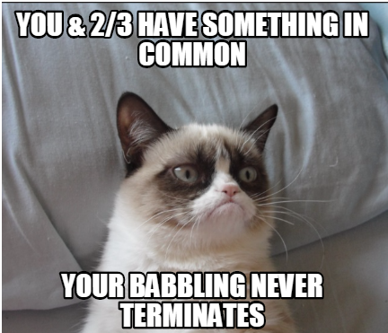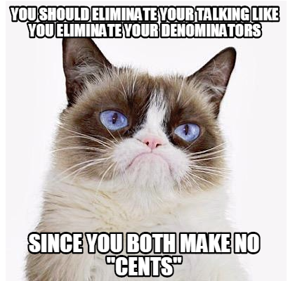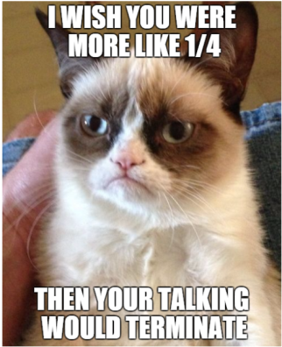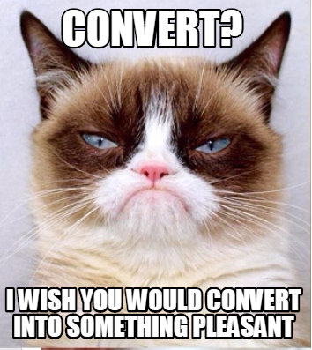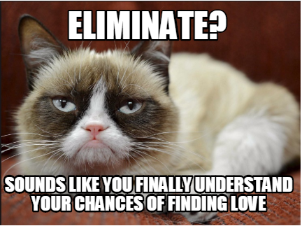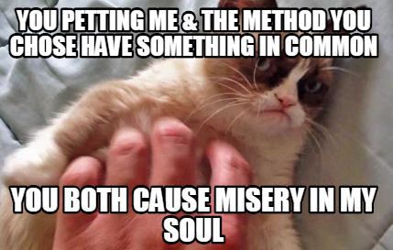
GRUMPY CAT MEMES
Choose from the memes here or create your own. They must contain math vocabulary and must be approved before created.
GOOD LUCK WITH YOUR MISSION!!

