Standardized Test Practice- Linear Functions

Read each question. Then fill in the correct answer on the answer document provided by your teacher or on a sheet of paper.

1. Which statement is true about the slope of line RT?
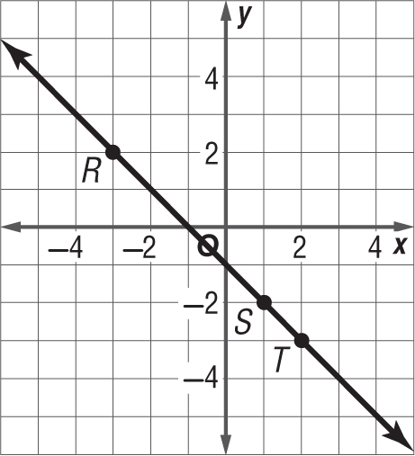

A. The slope is the same between any two points.
B. The slope between point R and point S is greater than the slope between point S and point T.
C. The slope between point R and point T is greater than the slope between point S and point T.
D. The slope is positive.

2. A truck used 6.3 gallons of gasoline to travel 107 miles. How many gallons of gasoline would it need to travel an additional 250 miles?
F. 8.4 gallons
G. 14.7 gallons
H. 18.9 gallons
I. 21.0 gallons

3. GRIDDED RESPONSE The cost of a pair of inline skates is $63. If the inline skates are on sale for 35% off, what is the sale price of the inline skates in dollars?

4. Which of the following is the graph of y = $\frac{3}{4}$x + 2?

A. C.
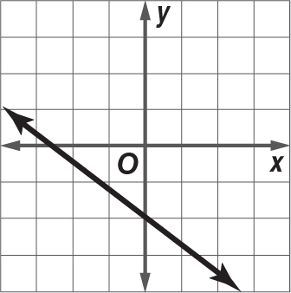
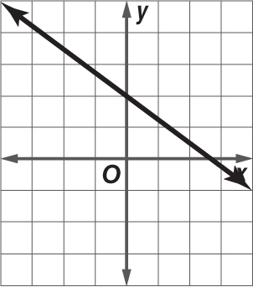

B. D.
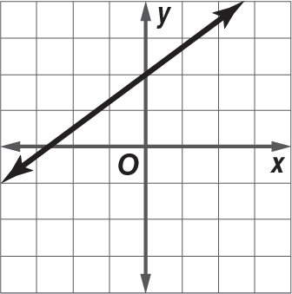
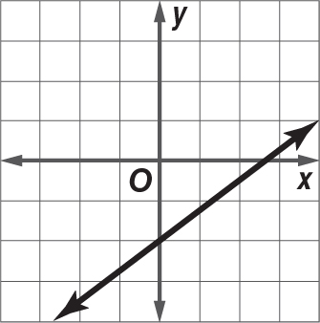

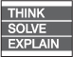
5. SHORT RESPONSE What are the slope and x- and y-intercepts of the equation below?

3x – 6y = 18

6. The table below shows how much Heather pays to rent DVDs.
Number  of DVDs | Cost ($)
2 | 5
4 | 10
6 | 15
8 | 20

Which of the following expressions can be used to find the total cost of renting any number n of DVDs?
F. 5n H. 5n – 2
G. 2.5n I. 2.5n – 2
7. GRIDDED RESPONSE What is the product of the fractions below?
$\frac{3}{5}$ • $\frac{10}{12}$

8. The equation c = 0.8t represents c, the cost of t tickets on a ferry. Which table contains values that satisfy this equation?

A.
Cost of Ferry Tickets
t | 1 | 2 | 3 | 4
c | $0.80 | $1.00 | $1.20 | $1.40

B.
Cost of Ferry Tickets
t | 1 | 2 | 3 | 4
c | $0.80 | $1.60 | $2.40 | $3.20

C.
Cost of Ferry Tickets
t | 1 | 2 | 3 | 4
c | $0.75 | $1.50 | $2.25 | $3.00

D.
Cost of Ferry Tickets
t | 1 | 2 | 3 | 4
c | $1.80 | $2.60 | $3.40 | $4.20

9. GRIDDED RESPONSE The slope of the line shown below is $\frac{4}{5}$.
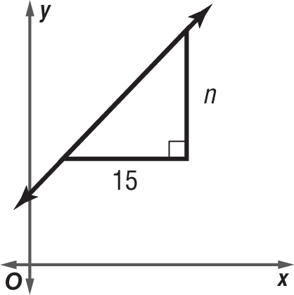

What is the value of n?

10. What is the solution of the system of equations below?
y = x – 4
y = 3x
F. (3, 4) H. (–2, –6)
G. (–3, 4) I. (2, 6)

11. What does the slope of the line in the graph below represent?
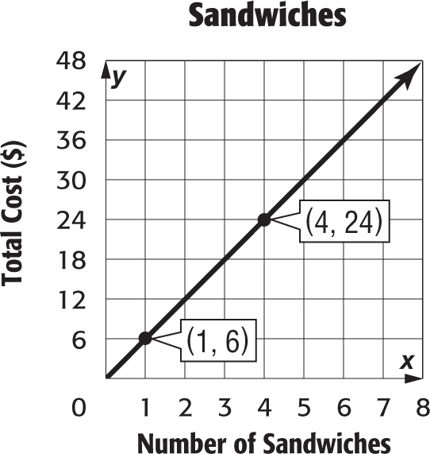

A. total number of sandwiches purchased
B. total cost of one sandwich
C. total cost of any number of sandwiches
D. None of the above

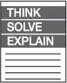
12. EXTENDED RESPONSE The table below shows the admission rates at the local aquarium.
Ticket | Price ($)
Adult | 15
Child | 9

Part A Mr. Reilly spent $90 on tickets to the aquarium. Write an equation in standard form to represent the situation.
Part B What are the x- and y-intercepts of the function? What do they represent?
Part C Write the equation from Part A in slope-intercept form.
Part D Graph the equation on a coordinate plane.
Part E What is the slope of the line? What does the slope represent?

