Lesson 8 Homework Practice
Solve Multi–Step Equations with Integers and Decimals
Solve each equation. Check your solution.
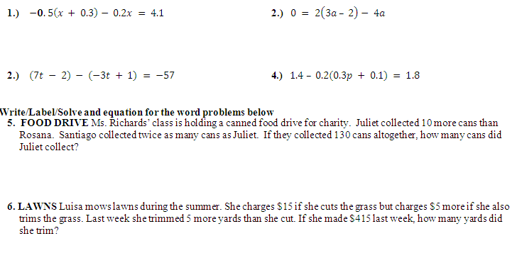
- $-0.5\left(x + 0.3\right)- 0.2x = 4.1$ 2.) $0 = 2\left(3a – 2\right)- 4a$

- $(7t - 2) - (-3t + 1) = -57$ 4.) $1.4 – 0.2(0.3p + 0.1) = 1.8$

Write/Label/Solve and equation for the word problems below
5. FOOD DRIVE Ms. Richards’ class is holding a canned food drive for charity. Juliet collected 10 more cans than Rosana. Santiago collected twice as many cans as Juliet. If they collected 130 cans altogether, how many cans did Juliet collect?

6. LAWNS Luisa mows lawns during the summer. She charges $15 if she cuts the grass but charges $5 more if she also trims the grass. Last week she trimmed 5 more yards than she cut. If she made $415 last week, how many yards did she trim?

