Lesson 8.3b Homework Practice

Distance on the Coordinate Plane Real-Life/Geometry Connections
Use the diagram below to answer questions 1. A triangular-shaped forest preserve is formed by roads AB, BC, and CA as shown on the map.  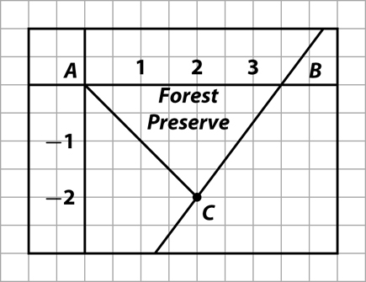 | 1.) Find its perimeter using the distance formula. The distances are in kilometers.
2.) Find the perimeter of the triangle | 3.) Find the area of the square below  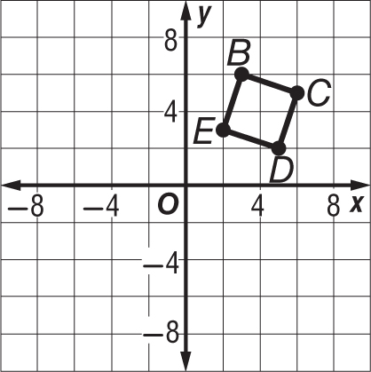
4. GEOMETRY The coordinates of points A, B, and C are (5, 4), (–2, 1), and (4, –4), respectively. Which point, B or C, is closer to point A? | 5. THEME PARK Bryce is looking at a map of a theme park. The map is laid out in a coordinate system. Bryce is at (2, 3). The roller coaster is at (7, 8), and the water ride is at (9, 1). Is Bryce closer to the roller coaster or the water ride?

