Lesson 5: Use The Pythagorean Theorem to Find Missing Hypotenuse
Homework Practice

Write an equation that can be used to answer the question. Then solve. Round to the nearest tenth if necessary.
Question 1 | Question 2
Question 3 | Question 4
How far is the ship from the light house? | How long is the wire supporting the sign?
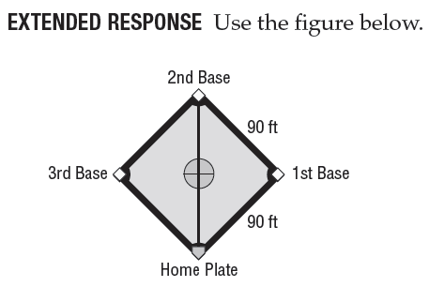Question 5: How far is the distance from home plate to
second base? Round to the nearest tenth.

