**Homework 5.3b: Composition (Sequence) of Transformations**

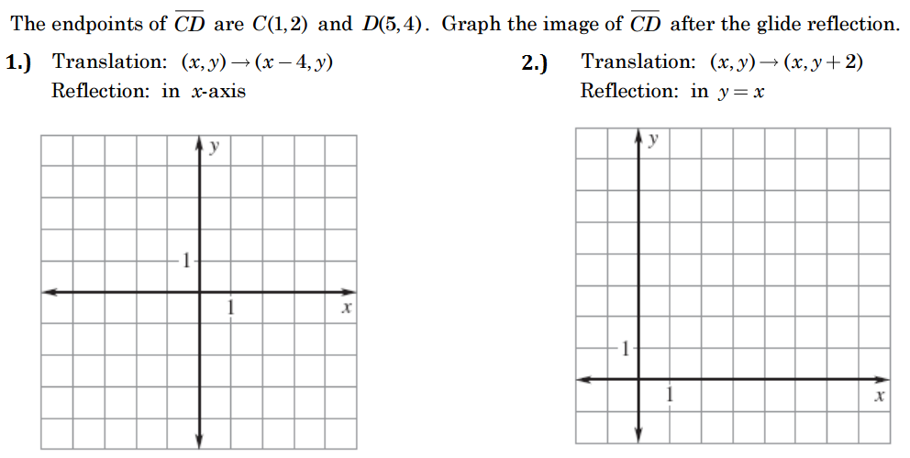



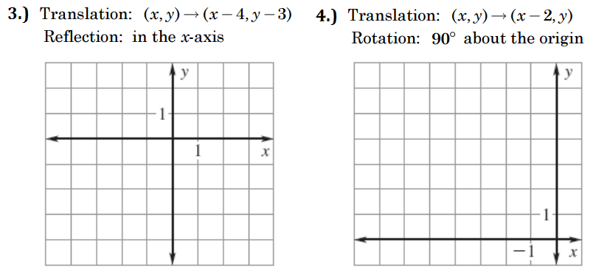

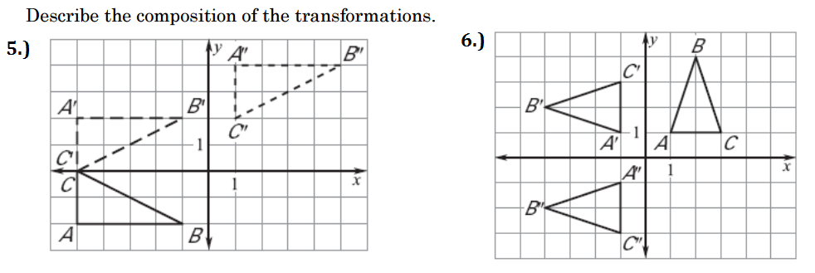

|  |  |
| --- | --- |
|  |  |
|  | Describe the sequence of transformations that took place. |
|  | Select ALL sequences that are possible below |

