Homework 5.2d_5.3a: Dilations

Dilations

Find the coordinates of the vertices of each figure after a dilation with the given scale factor k. Then graph the original image and the dilation.

1. J(–4, –1), K(0, 4), L(–4, –2); $k=\frac{1}{2}$ 2. R(–2, 1), A(1, 1), I(0, –1), N(–1, –1); k = 2
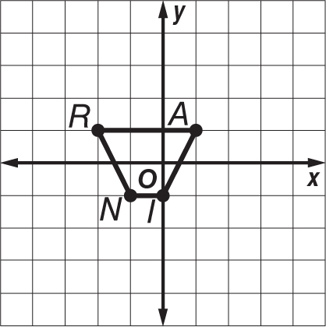
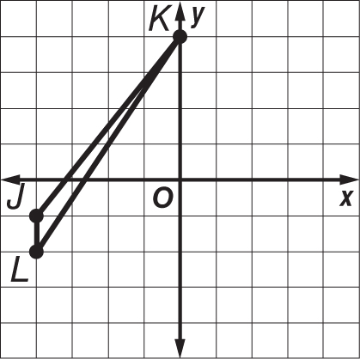

3. P(–3, 3), Q(6, 3), R(6, –3), S(–3, –3); $k=\frac{1}{3}$ 4. A(1, –2), B(2, 1), C(3, 0); k = 3
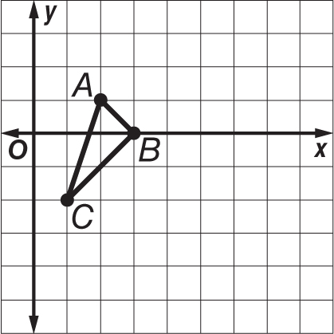
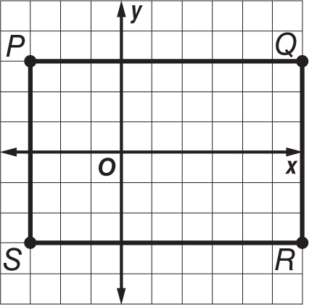

5. PHOTOS Kiesha used a photo that measured 4 inches by 6 inches to make a copy that measured 8 inches by 12 inches. What is the scale factor of the dilation?

6. MODELS David built a model of a regulation basketball court. His model measured approximately 3.75 feet long by 2 feet wide. The dimensions of a regulation court are 94 feet long by 50 feet wide. What is the scale factor David used to build his model?

7. BLUEPRINTS On the blueprints of Mr. Wong’s house, his great room measures 4.5 inches by 5 inches. The actual great room measures 18 feet by 20 feet. What is the scale factor of the dilation?

Transformational Geometry Task

Use the diagram and information below to answer questions a, b, c and d for question #1
Below are two diagrams. One represents a reflection and one represents a rotation. 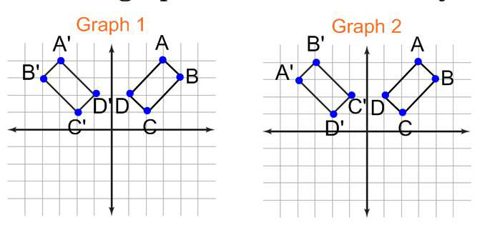

1. a.) Which graph represents the reflection? Answer_____________________

b.) On the lines below explain how you know the graph you chose represents a reflection? Use proper math vocabulary in your explanation.

__________________________________________________________________________________________________

__________________________________________________________________________________________________

__________________________________________________________________________________________________

__________________________________________________________________________________________________

__________________________________________________________________________________________________

__________________________________________________________________________________________________

c.) Which graph represents the rotation? Answer_____________________

d.) On the lines below explain how you know the graph you chose represents a rotation? Use proper math vocabulary in your explanation and state the rotation degree.

__________________________________________________________________________________________________

__________________________________________________________________________________________________

__________________________________________________________________________________________________

__________________________________________________________________________________________________

