Lesson 4 Homework Practice: Graph Function Tables
Analyze: (Circle)

Increasing/Decreasing

Steep/Not Steep

Proportional/
Non-Proportional

Domain: (x-values)
Positive/Negative

Range: (y-values)
Positive/Negative
Graph:
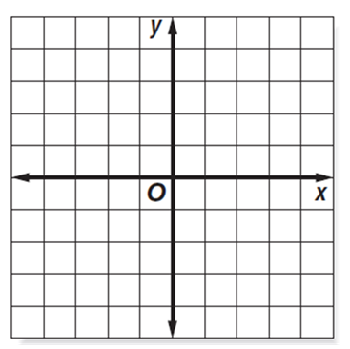
- Complete the function table below
x | Y = 3x -1 | y | (x, y)
-2
-1
0
1
2
3

Analyze: (Circle)

Increasing/Decreasing

Steep/Not Steep

Proportional/
Non-Proportional

Domain: (x-values)
Positive/Negative

Range: (y-values)
Positive/Negative
Graph:
- Complete the function table below
x | Y = -2x | y | (x, y)
-2
-1
0
1
2
3

3. Efrain has $11 in his bank account and spends $3 each day for him and his friends on snacks. He uses his debit card to pay for the snacks. How many days can Efrain buy his friends snacks before he goes into debt?
Analyze: (Circle)

Increasing/Decreasing

Steep/Not Steep

Proportional/
Non-Proportional

Domain: (x-values)
Positive/Negative

Range: (y-values)
Positive/Negative

Graph: (Label Everything)

Complete the function table below
Let x =__________________________
Let y =__________________________

x | Y = | y | (x, y)
0
1
2
3
4
5
When will Efrain go into debt?

