Lesson 4.2bc Homework Practice: Proportional/Non-Proportional Functions
Determine if the functions below are proportional/non-proportional & increasing/decreasing
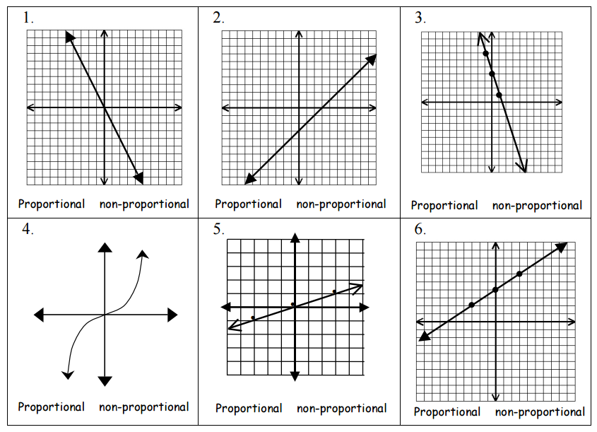
7.) y = ¾ x + 1 | 8.) xy = 10 | 9.) y + x = 3
10.)

11.) What is the value of x in the equation:  2x − 15 = −3x + 5?  A 2 C 4  B 3 D 5 | 15.) Which of the following lists shows the numbers below in order from least to greatest?  0.65, 6 × 10⁻⁴, 6 × 10⁻², 0.065  A 6 × 10⁻⁴, 6 × 10⁻², 0.065, 0.65  B 0.65, 0.065, 6 × 10⁻², 6 × 10⁻⁴  C 6 × 10⁻², 6 × 10⁻⁴, 0.065, 0.65  D 6 × 10⁻⁴, 0.065, 6 × 10⁻², 0.65
12.) Which equation below has no solution?  A 2(2x + 1) = 4x + 2  B 3x + 7 = x  C 3x + 6 = x + 2  D 5x + 1 = 5x − 3 | 16.)  x 1 1 4 5  y 2 5 2 6  x 1 1 4 5  y 2 5 2 6
13.) How is the number below written in scientific notation?
120
A 1.2 × 10¹
B 12 × 10¹
C 1.2 × 10²
D 12 × 10²
14.) Which equation shows a non-proportional relationship?  A y = −2x C y = 2x + 0  B y = x D y = 2x + 2 | 17.) Which of the following sets of ordered pairs does not represent a function?  A {(1, 2), (2, 3), (4, 5), (3, 3)}  B {(−1, 3), (2, 3), (6, 5), (7, 3)}  C {(1, 2), (1, 3), (−4, 5), (3, 8)}  D {(−1, 2), (2, 2), (4, 2), (3, 2)}

