NAME________________________________________CLASS___________DATE_____________ 4-6D NOTES
4-6d: to apply addition/subtraction to evaluate functions using function notation

$f\left(x\right)=x^{2}-1$ $g\left(x\right)=2x-3$ $h\left(x\right)=1-4x$
- $g\left(x\right)+h(x)$ | - $g\left(x\right)-h(x)$ | - $(g+f)(x)$ | - $(g-f)(x)$
- $g\left(3\right)+h(3)$ | - $g\left(3\right)-h(3)$ | - $(g+f)(-2)$ | - $(g-f)(-2)$
- $f\left(x\right)+h(x)$ | - $(f-g)(4)$ | - $h\left(-3\right)-g(-3)$ | - $(h+h)(x)$
- $h\left(4\right)+f(2)$ | - $(h-f)(x)$ | - $h\left(x\right)+g(x)$ | - $f\left(-1\right)+g(3)$
NAME________________________________________CLASS___________DATE_____________ 4-6D PRACTICE
4-6d: to apply addition/subtraction to evaluate functions using function notation
1 | 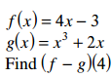 | 2 | 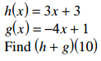 | 3 | 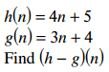
4 | 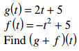 | 5 | 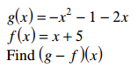 | 6 | 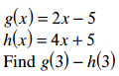
7 | 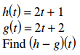 | 8 | 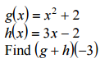 | 9 | 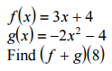
10 | 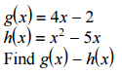 | 11 | 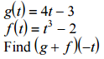 | 12 | 