NAME DATE PERIOD
Lesson 3.2abc Graph Linear Functions Homework Practice
- Complete the function table below |  | Analyze: (Circle)  Increasing/Decreasing  Steep/Not Steep  Proportional/  Non-Proportional  Above Origin/ Below Origin
- Complete the function table below |  | Analyze: (Circle)  Increasing/Decreasing  Steep/Not Steep  Proportional/  Non-Proportional  Above Origin/ Below Origin

#3-8: Graph liner functions without using tables (Label x/y axis + line)
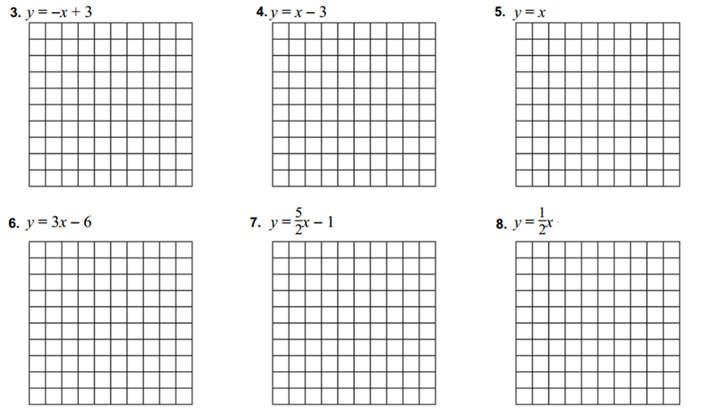

#9-11: Identify the x and y-intercepts of the graphs below
9.) | 10.) | 11.) *Scale
x- Intercept:  y-intercept: | x- Intercept:  y-intercept: | x- Intercept:  y-intercept:

#12-13-Graph the linear functions below using the x and y-intercepts
12.) 3x – 5y = 15  x-intercept y-intercept | 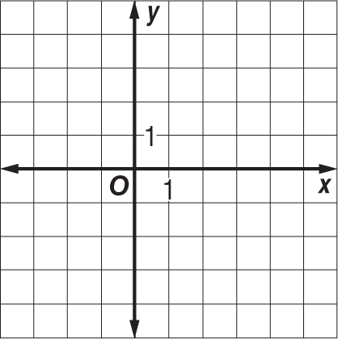
13.) $-\frac{1}{2}$x + 3y = –3
x-intercept y-intercept

