Lesson 3.1def Homework Practice: Write Linear Equations (20 Points)

Write an equation in slope-intercept form
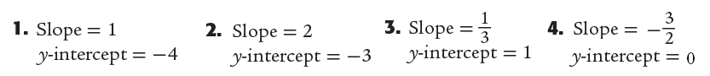
y =______________ y =_____________ y =____________ y =_____________

Question 5 | Question 6 | Question 7 | Question 8
 | 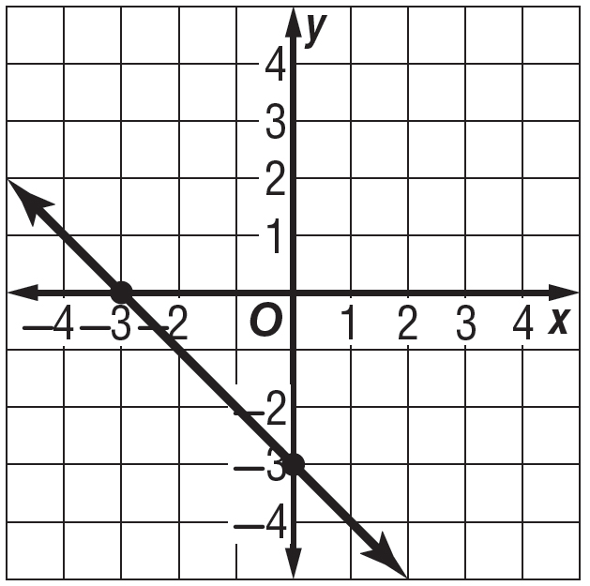
m = _____ b = _____  y =________________ | m = _____ b = _____  y =________________ | m = _____ b = _____  y =________________ | m = _____ b = _____  y =________________  **Watch Scale**
Question 9 | Question 10 | Question 11 | Question 12
m =  b = | m =  b = | x –1 0 1 2 3  y 4 2 0 -2 -4  m = b = | m = b =
Equation of Line: | Equation of Line: | Equation of Line: | Equation of Line:

State the slope and the y-intercept for the graph of each equation.

13. y = 4x + 1 14. y = –3x + 5 15. –x + y = 4

16. y = $\frac{5}{6}x$ – 3 17. 2y + 3x = –8 18. y = $\frac{1}{5}x$ + 2

19. WEATHER The equation y = 0.2x + 3.5 can be used to find the amount of accumulated snow y in inches x hours after 5 P.M. on a certain day. Identify the slope and y- intercept of the graph of the equation and explain what each represents. | 20. SALARY Janette’s weekly salary can be represented by the equation y = 500 + 0.4x, where x is the dollar total of her sales for the week. Identify the slope and y-intercept of the graph of the equation and explain what each represents.
21.) Find the missing x, y values and write the equation of the line  Equation:_________________________________ | 22.) Find the missing x, y values and write the equation of the line  Equation:_________________________________

