Lesson 3.1abc Homework Practice: Find the Slope
Find the slope of each line.
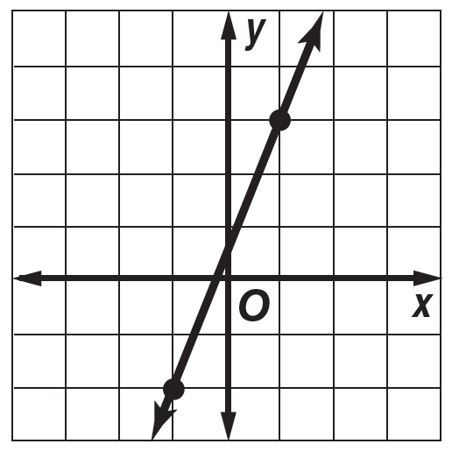
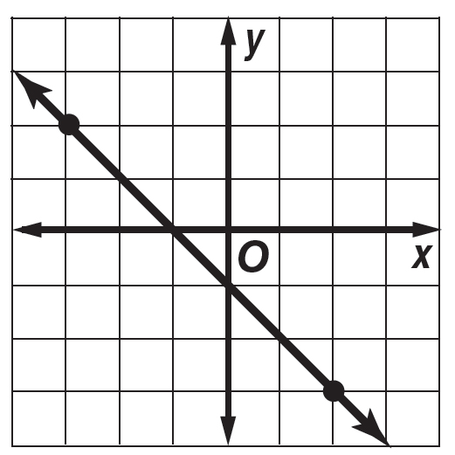
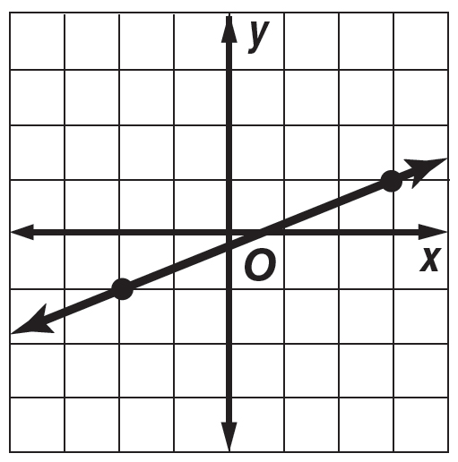
1. 2. 3.

Find the slope of the line that passes through each pair of points.

4. A(1, 3), B(4, 7) 5. C(3, 5), D(2, 6) 6. E(4, 0), F(5, 5)

The points given in each table lie on a line. Find the slope of the line.
x | –1 | 1 | 3 | 5
y | –2 | 0 | 2 | 4

x | –1 | 2 | 5 | 8
y | 3 | –1 | –5 | 9

x | –2 | 3 | 8 | 13
y | –2 | –1 | 0 | 1

7. 8. 9.

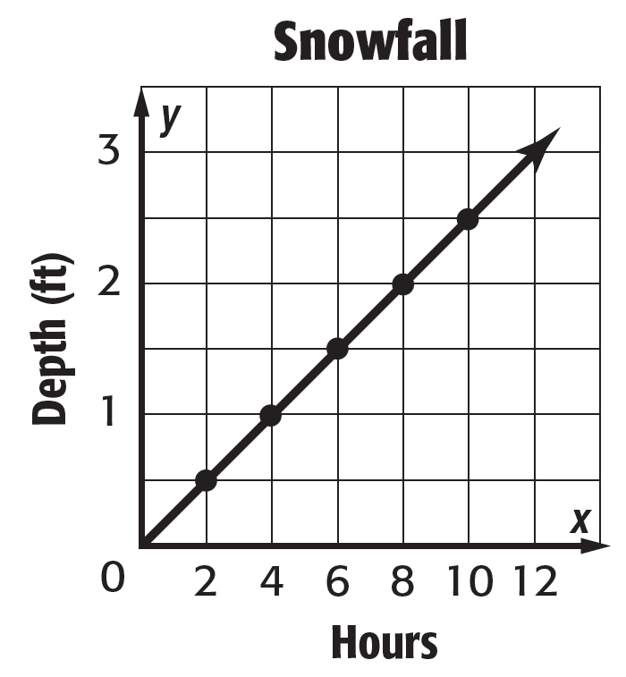
10. SNOWFALL Use the graph at the right. It shows the depth in feet of snow after each two-hour period during a snowstorm.

a. Find the slope of the line.
b. Does the graph show a constant rate of change? Explain.

c. If the graph is extended to the right, could you expect the slope to remain constant? Explain.
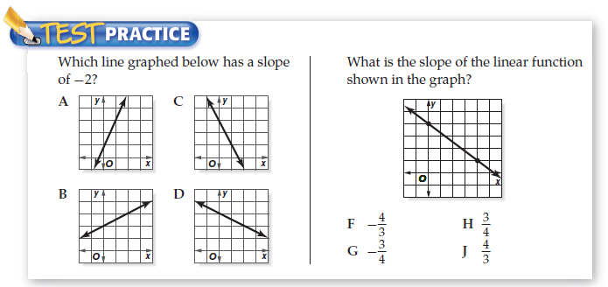

Question 13: Use the information below to answer all parts for question 1  CLEANING SERVICE A cleaning service company charges $75 for 2 hours of service and $135 for 4 hours of service. How much does the cleaning service change for each hour? | Question 14: Use the information below to answer all parts for question 1  BABY-SITTING If you babysit for 5 hours, you make $60. If you babysit for 7 hours you make $84. How much do you charge per hour?
- Let statements  Let x =____________ Let y =____________ | - Let statements  Let x =____________ Let y =____________
- Identify and label coordinates  #1( , ) #2( , ) | - Identify and label coordinates  #1( , ) #2( , )
- Find the slope: Show all work | - Find the slope: Show all work
- Write a real-life sentence to represent the slope | - Write a real-life sentence to represent the slope
- Is this line proportional/Non-Proportional? Show work/Explain | - Is this line proportional/Non-Proportional? Show work/Explain
- EXTENTION: If it is not proportional, what do you think the fee is for the cleaning service? | - EXTENTION: Do you charge a travel fee for babysitting? If so, how much?
#15.) In a basketball game, Benito scored 3 points less than twice the number of points Carnell scored. Carnell scored 8 points. How many points did Benito score?

F. 5 points G. 11 points H. 13 points I. 16 points

