Lesson 2 Homework Practice: Translations
Draw the image of the figure after the indicated translation. Don’t forget to write the rule
1. 3 units right and 2 units up | 2. 4 units left and 2 units  down | 3. 2 units left and 1 unit up
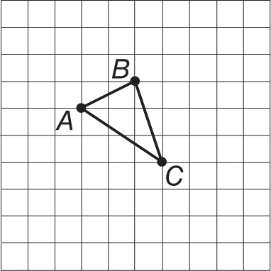 | 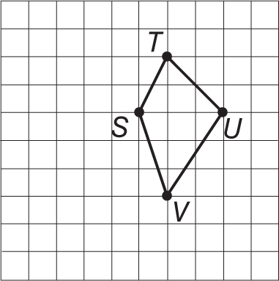 | 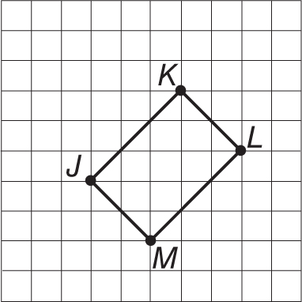
Rule: | Rule: | Rule:

Graph the figure with the given vertices. Then graph the image of the figure after the indicated translation, and write the coordinates of its vertices. Don’t forget to write the rule
5. ∆FGH with vertices F(1, 3),  G(2, 4), and H(3, 2); translated 3 units  left and 1 unit down | 6. Rectangle PQRS with vertices P(–4,–1),  Q(0, 1), R(1,–1), and S(–3,–3) translated 2 units right and 3 units up
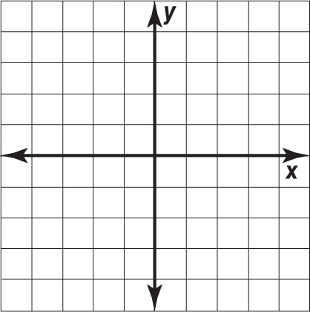
Rule: | Rule:

What is the rule for the translation to the right?

