Lesson 2 Homework Practice: Slope Formula
Find the slope of each line using the formula and two points from the line
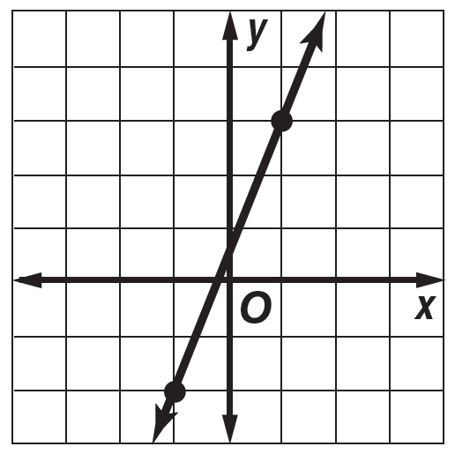
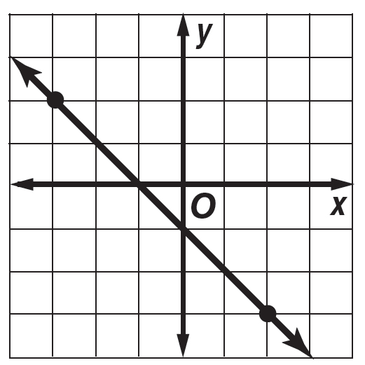
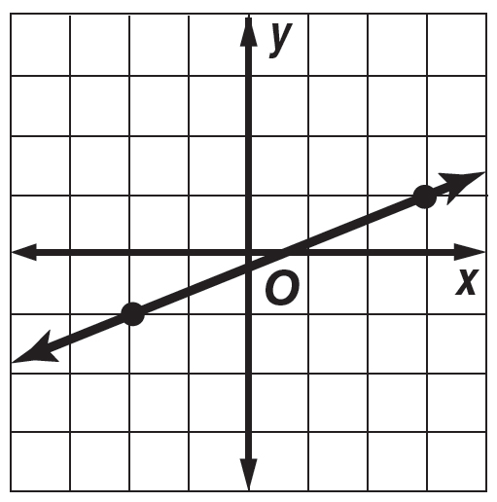
1. 2. 3.

The points given in each table lie on a line. Find the slope of the line.
x | –1 | 1 | 3 | 5
y | –2 | 0 | 2 | 4

x | –1 | 2 | 5 | 8
y | 3 | –1 | –5 | 9

x | –2 | 3 | 8 | 13
y | –2 | –1 | 0 | 1

4. 5. 6.

Find the slope of the line that passes through each pair of points.

7. A(1, 3), B(4, 7) 8. C(3, 5), D(2, 6) 9. E(4, 0), F(5, 5)

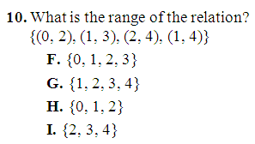 | 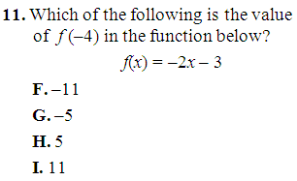 | 