Lesson 2-3d Consecutive Integer Equations Homework
Must show all work + let statements
1 | Find two consecutive integers whose sum is 61  30, 31 | 2 | Find two consecutive integers whose sum is -17  -9, -8
3 | Find three consecutive integers whose sum is 48  15, 16, 17 | 4 | Find three consecutive integers whose sum is -57  -20, -19, -18
5 | Find three consecutive even integers whose sum is 156  50, 52, 54 | 6 | Find three consecutive even integers whose sum is -60  -22, -20, -18
7 | Find three consecutive odd integers who sum is 33  9, 11, 13 | 8 | Find three consecutive odd integers who sum is -105  -37, -35, -33
9 | Find four consecutive odd integers whose sum is 112  25, 27, 29, 31 | 10 | Find four consecutive even integers whose sum is 60  12, 14, 16, 18
11 | **Challenge** Three consecutive even integers such that the sum of the first & the third is 40  19, 20, 21 | 12 | **Challenge** Four consecutive integers such that the sum of the second and the fourth is 132  64, 65, 66, 67
13.) 7th Grade: Inequalities (Multiple Choice)
WORD PROBLEM | MULTIPLE CHOICE | Solve/Graph Inequality below
Tracy has $35 to buy comic books and to pay for a movie ticket. Each comic book costs $3. The movie ticket costs $10. Which inequality can be used to determine how many comic books, b, Tracy can buy? B |  | b ≤ 8⅓ or  b ≤ 8  (don’t forget to switch the sign when dividing a negative)

14.) 7th Grade: Proportional Relationships
WORD PROBLEM | MULTIPLE CHOICE | Solve Show all work
A box of sunflower seeds contains p packets. Each packet of sunflower seeds contains s seeds. Which equation can be used to find the number of sun flower seeds in a box, b? C |  | - If there are 100 seeds in each packet, and there are 5 packets, how many seeds are in the box?  500  - If there are 1200 seeds total and 60 packets, how many seeds are in each packet?  20
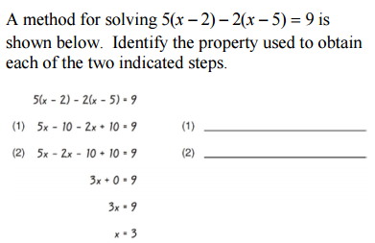
REGENTS PREP: Identify Properties
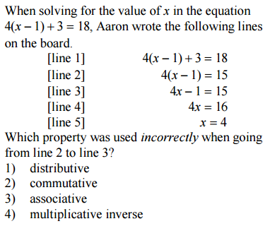
15.) 16.)

