***Lesson 2-3c Solve Multi-Step Equations w/ Rationals (Fractions/Decimals) Homework***

|  |  |  |
| --- | --- | --- |
|  | SOLVE | **CHECK** |
| **1** | $$1.4 – 0.2(0.3p + 0.1) = 1.8$$ | $$1.4 – 0.2(0.3p + 0.1) = 1.8$$ |
| **2** | $$-0.5\left(x + 0.3\right)- 0.2x = 4.1$$ | $$-0.5\left(x + 0.3\right)- 0.2x = 4.1$$ |
| **3** |  |  |
| **4** | $$\frac{1}{8}\left(3y+2\right)-\frac{1}{2}=1\frac{3}{8}$$ | $$\frac{1}{8}\left(3y+2\right)-\frac{1}{2}=1\frac{3}{8}$$ |
| **5** |  |  |
| **6** | $$\frac{2}{7}\left(14q+\frac{7}{2}\right)-3q=9$$ | $$\frac{2}{7}\left(14q+\frac{7}{2}\right)-3q=9$$ |



***Simplify original expression, then simplify ABC. If you get the same simplifed expression, check yes, if you get a different exressio, check no. MUST SHOW WORK FOR CREDIT!!***

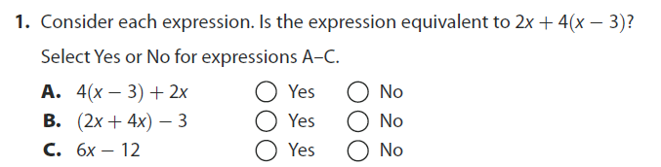

***Substitute seconds from ABC into expression. If the answer is the height, check yes. If the answer is not the height, check no. MUST SHOW WORK FOR CREDIT!!!***

