Lesson 3.4a Homework Practice-Systems by Graphing
DIRECTIONS: Write the equation of each line and state the point of intersection
Question 1 | Question 2 | Question 3*

DIRECTIONS: Solve each system of equation by graphing

Question 4 | Question 5 | Question 6
Line 1: y = 3x + 4 Line 2: y = -x – 4  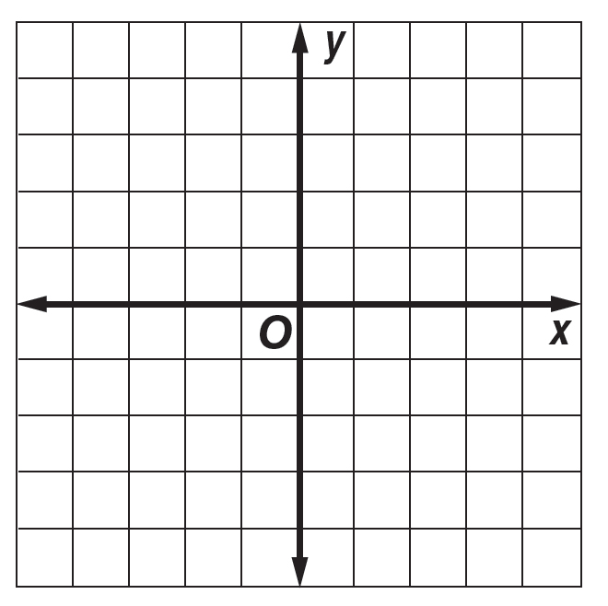 | Line 1: y = ½ x – 3 Line 2: y = –3 | Line 1: y = x – 1 Line 2: y – x = –1

