Lesson 1 Homework Practice: Slope on a Graph
Find the slope of each line.
1. 2. 3.

Plot the point stated, then graph the line using the slope
4. Graph a line with a 5. Graph a line with a 6.Graph a line with a
slope of 1 and a slope of 2 and a slope of $\frac{1}{3}$ and a
point of (0, –4) point of (0, –3) point of (0, 1)

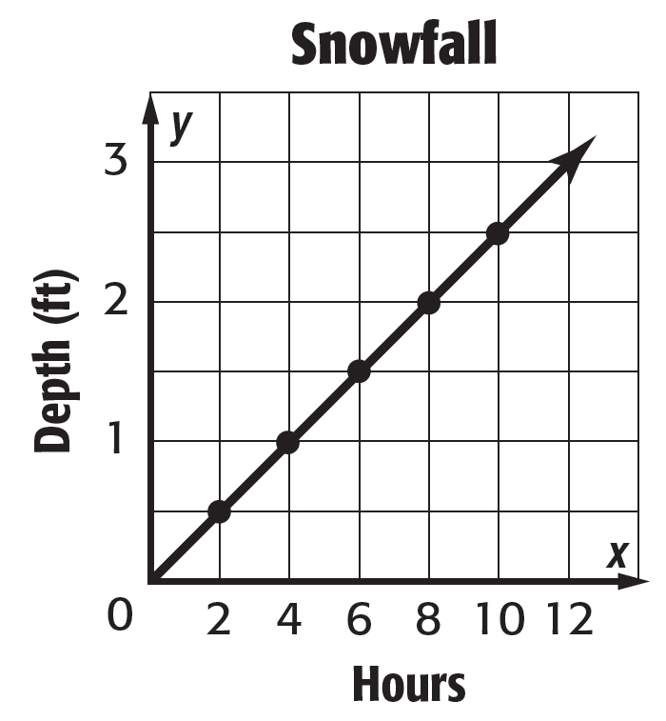
7. SNOWFALL Use the graph at the right. It shows the depth in feet of snow after each two-hour period during a snowstorm.

a. Find the slope of the line.
b. Does the graph show a constant rate of change? Explain.

c. If the graph is extended to the right, could you expect the slope to remain constant? Explain.

