Lesson 1: Homework Practice

Integers and Graphing

Write an integer for each situation. Explain the meaning of zero in each situation.

1. a drop of 200 feet 2. an expansion of 3 cubic meters

3. earn 10 points 4. reduce by 8 inches

5. gain 2 pounds 6. a drop of 7 degrees

Graph each set of integers on a number line.
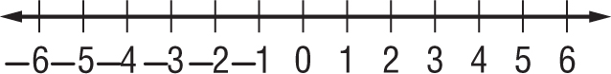
7. {–4, –3, 1, 5}

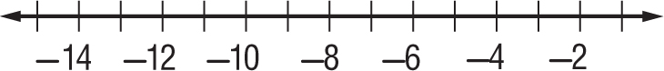
8. {–15, –12, –9, –2}

9. BUSINESS Ms. Solorio’s small business had a profit of $460 on Monday. Write an integer to represent this profit.

10. CAVING The end of a cave is 380 meters below the surface of the earth. Write an integer to represent this depth.

11. TEMPERATURE The low temperatures for three consecutive days were –5°F, 3°F, and 4°F. Graph this set of integers on a number line.
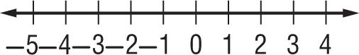

12. ELEVATIONS The lowest elevation in New Orleans, Louisiana, is –8 feet. The lowest elevation in Long Beach, California, is –7 feet. Graph this set of integers on a number line.
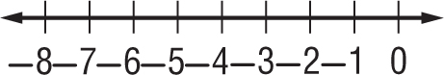

13. Jackson owes his sister Monica $15. On the lines below explain the meaning of zero in this situation.
___________________________________________________________________________________
___________________________________________________________________________________
___________________________________________________________________________________
___________________________________________________________________________________

