Lesson 6 Homework Practice

Write Linear Equations

Write an equation in point-slope form and slope-intercept form for each line.

1. passes through (–5, 6), slope = 3 2. passes through (6, –6), slope = 5

3. passes through (0, 1) and (2, 5) 4. passes through (–5, 9) and (1, 3)

5. passes through (1, –1) and (2, 0) 6. passes through (–3, –5), slope = 2

Write the point-slope form of an equation for each line graphed.
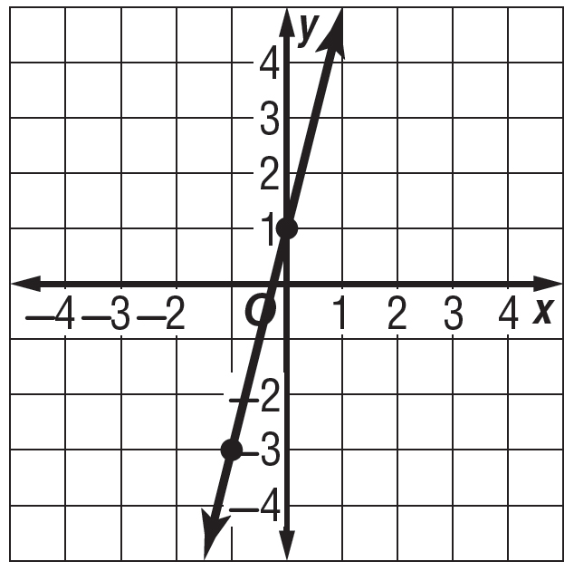
7. 8.
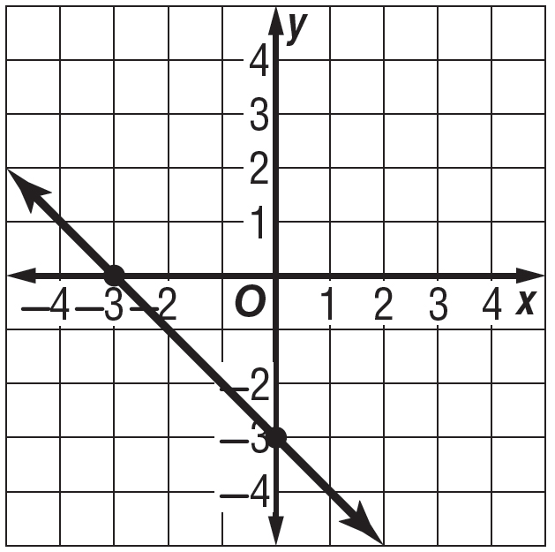

Hour | Temperature  (°F)
1 | 35
2 | 39

9. TEMPERATURE The table shows the temperature at certain hours. Assuming the temperature change is linear, write an equation in point-slope form to represent the temperature y at x hour.

10. SPEED After 2 hours, a car travels 70 miles. After 2.25 hours in the same trip, the car travels 78.75 miles. Write an equation in point-slope form to represent the distance y of the car after x hours.

