Lesson 1.2 Homework Practice

Negative Exponents

Write each expression using a positive exponent.

1. $8^{-5}$ 2. $3^{-9}$ 3. $z^{-2}$ 4. $p^{-4}$

Evaluate each expression.

5. ${(-6)}^{-5}$ 6. $8^{-4}$ 7. $2^{-9}$ 8. ${(-7)}^{-9}$

Write each fraction as an expression using a negative exponent.

9. $\frac{1}{2^{9}}$ 10. $\frac{1}{64}$ 11. $\frac{1}{e^{5}}$ 12. $\frac{1}{7^{4}}$

Simplify. Express using positive exponents.

13. $\frac{6^{5}}{6^{2}}$ 14. $n^{-2}•n^{-3}$ 15. $\frac{w^{3}}{w^{-1}}$ 16. $\frac{k^{-4}}{k^{-6}}$

Rewrite using positive exponents
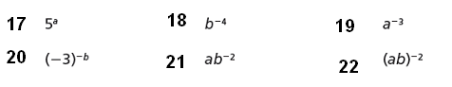

Explain on the lines below, how you rewrote question 21 using positive exponents.

______________________________________________________________________________________________________________________________________________________________________________________________________________________________________________________________________________________________________________________________________________________________________________________

