Homework Practice

Similar Triangles and Indirect Measurement

In Exercises 1– 4, the triangles are similar. Write a proportion and solve the problem.

1. TREES How tall is Yori?
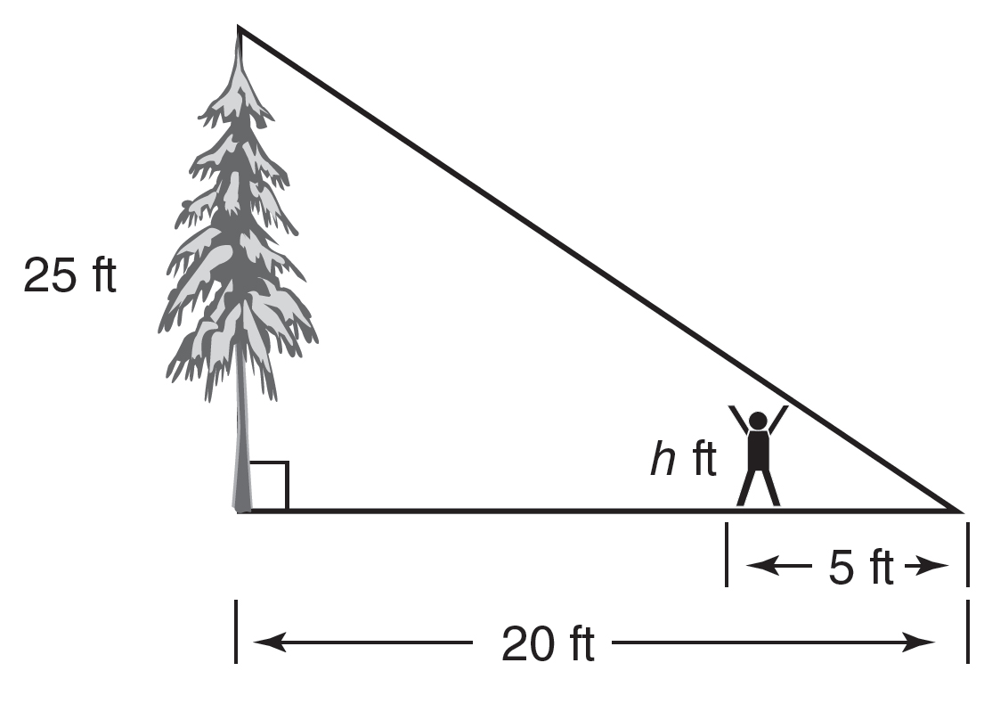
2. TREASURE HUNT How far is it from the hut to the gold coins?

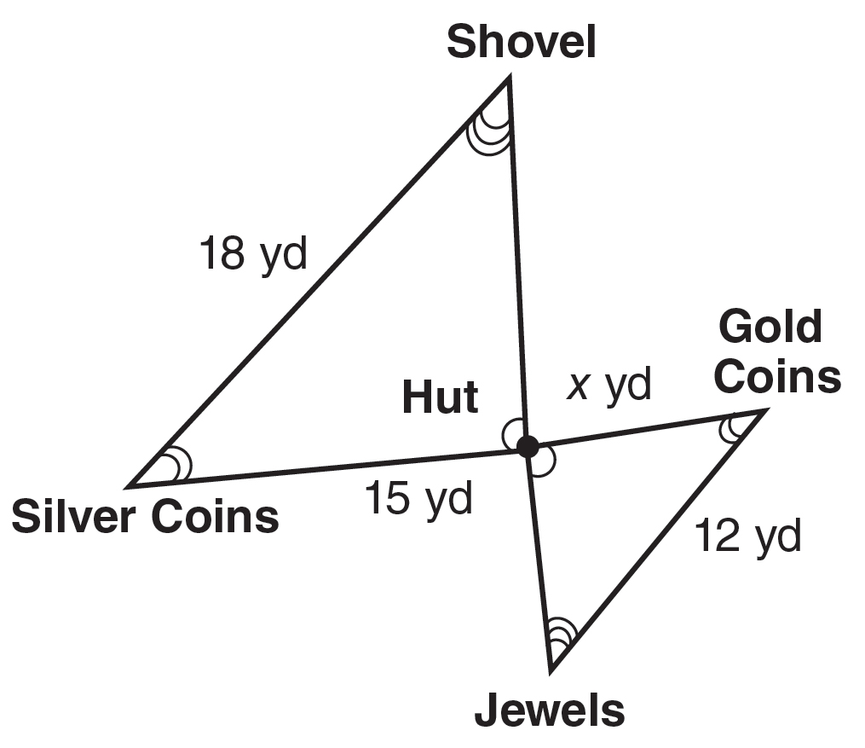

3. LAKE How deep is the water 31.5 feet from the shore?
4. SURVEYING How far is it across the pond?
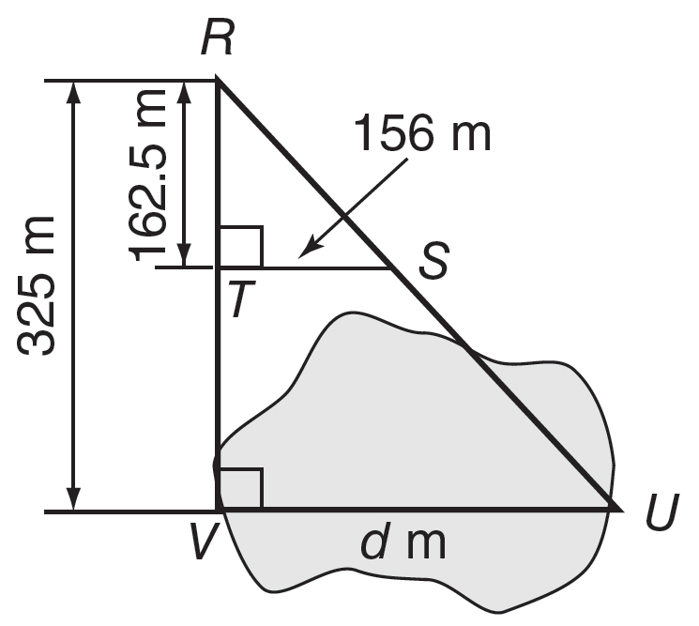

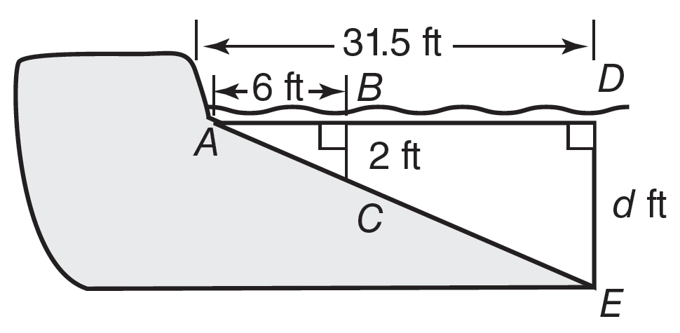

For Exercise 5, draw a diagram of the situation. Then rite a proportion and solve the problem.

5. ARCH The Gateway Arch in St. Louis, Missouri, is 630 feet tall. Suppose a 12-foot-tall pole that is near the Arch casts a 5-foot shadow. How long is the Arch’s shadow?

