Name____________________________________________________Class_____________Date____________
HW 5-8A Graphing & Translating Absolute Value Functions
Describe the Translation from $y=\left|x\right|$ & Write the equation
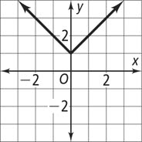 | Question 1  Describe translation:  Equation: | 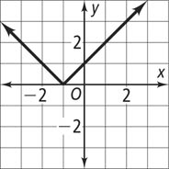 | Question 2  Describe translation:  Equation:
Graph the Absolute Value Functions below. Label equation, vertex & describe translation
3. y = |x| + 2 | 4. y = |x| – 5 | 5. y = | x | – 3 | 6. y = | x | + 1.5
7. y = |x + 7| | 8. y = |x - 4| | 9. y = |x + 5| | 10. y = |x - 3|
11. y = |x + 1| – 4 | 12. y = |x – 3| + 2 | 13. y = |x –1| – 3 | 14. y = |x + 2| + 1
15. y = |x + 1| + 5 | 16. y = |x – 2| + 2 | 17. y = |x – 4| – 2 | 18. y = |x + 5| – 1

