Homework Practice

Estimate Roots

Estimate to the nearest integer.

1. $\sqrt{38}$ 2. $\sqrt{53}$ 3. $\sqrt{99}$ 4. $\sqrt{227}$

GEOMETRY The formula for the area of a square is A = s², where s is the length of a side. Estimate the length of a side for each square.
5.) Ms. Passarella has a square poster that is 40 square inches. She wants to cover the square poster with a leopard border which she needs to purchase. She needs to find the side length of the square to be able to measure the border.

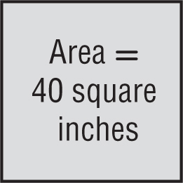

- Estimate the side length of the square- Show all work

- On the lines below explain how you find the estimated side length
_______________________________________________________________________________________________________________________________________________________________________________________________________________________________________________________________________________________________________________________________________________________________________________________________________________________________________________________________________
______________________________________________________________________________________________________________________________________________________________________________________
- Estimate the amount of leopard border Ms. Passarella needs to purchase by finding the perimeter-Show all work

