Direct Variation Homework Practice

Equations in y = mx Form
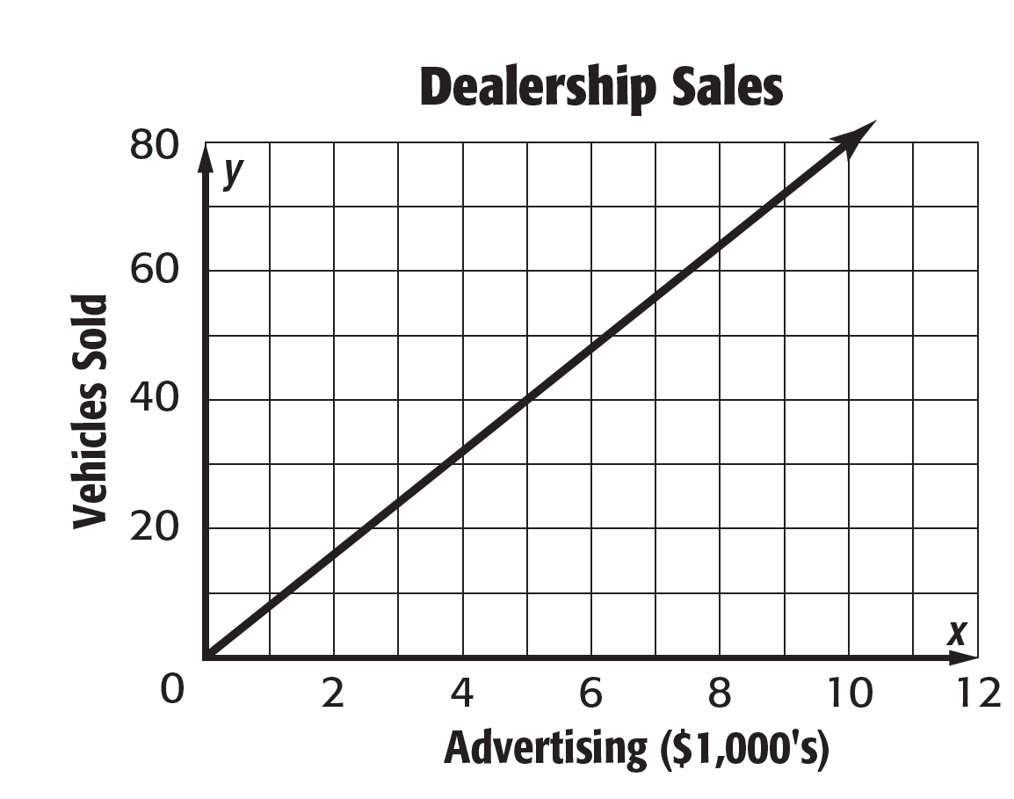
1. ADVERTISING The number of vehicles a dealership sells varies directly with the money spent on advertising. How many vehicles does the dealership sell for each $1,000 spent on advertising?

2. SNOWMOBILES Bruce rents snowmobiles to tourists. He charges $135 for 4 hours and $202.50 for 6 hours. What is the hourly rate Bruce charges to rent a snowmobile?

3. SOLAR ENERGY The power absorbed by a solar panel varies directly with its area. If an 8 square meter panel absorbs 8,160 watts of power, how much power does a 12 square meter solar panel absorb?

4. INSECT CONTROL Mr. Malone used 40 pounds of insecticide to cover 1,760 square feet of lawn and 60 pounds to cover an additional 2,640 square feet. How many pounds of insecticide would Mr. Malone need to cover his whole lawn of 4,480 square feet?

Determine whether each linear function is a direct variation. If so, state the constant of variation.

5. 6.
Volume, x | 2 | 4 | 6 | 8
Mass, y | 10 | 20 | 30 | 40

Gallons, x | 5 | 10 | 15 | 20
Miles, y | 95 | 190 | 285 | 380

7. 8.
Age, x | 3 | 6 | 9 | 12
Height, y | 28 | 40 | 52 | 64

Time, x | 8 | 9 | 10 | 11
Temp, y | 68 | 71 | 74 | 77

ALGEBRA If y varies directly with x, write an equation for the direct variation. Then find each value.

9. If y = –5 when x = 2, find y when x = 8.

10. Find y when x = 1, if y = 3 when x = 2.

11. If y = –7 when x = –21, what is the value of x when y = 9?

12. Find x when y = 18, if y = 5 when x = 4.

