Homework Practice

The Coordinate Plane

Use the coordinate plane at the right. Identify the point
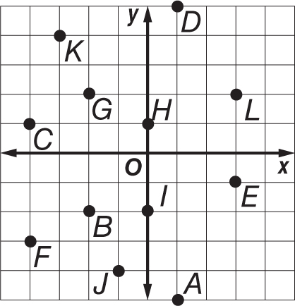
for each ordered pair.

1. (–3, 4) 2. (–4, –3)

3. (–2, –2) 4. (3, –1)

5. (0, 1) 6. (–1, –4)

Graph the ordered pair on the coordinate plane
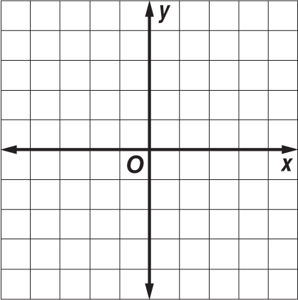
7. C(0, 0) 8. S(–2, 3)

9. D(–1, –3) 10. A(4, 0)

11. G(–1, 4) 12. I(3, 3)

Use the map of the Alger Underwater Preserve in Lake Superior to answer the following questions.
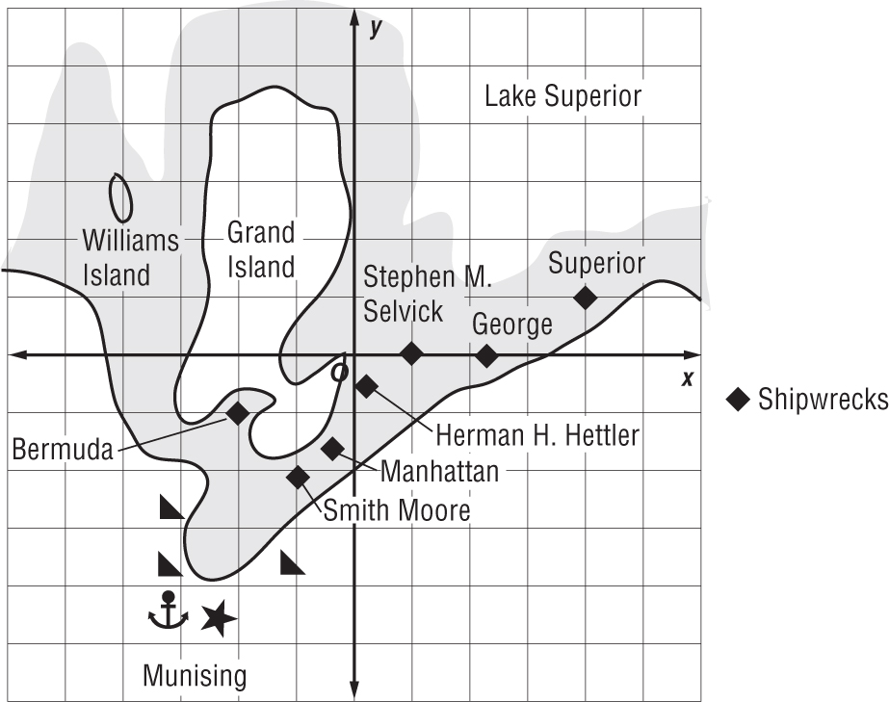
13. In which quadrant is the Stephen M. Selvick located?

14. What is the ordered pair that represents the location of the Bermuda? the Superior?

15. Which quadrant contains Williams Island?

16. Which shipwreck is closest to the origin?

