Lesson 3 Homework Practice

Area of Composite Figures

Find the area of each figure. Round to the nearest tenth if necessary.

1. 2. 3.
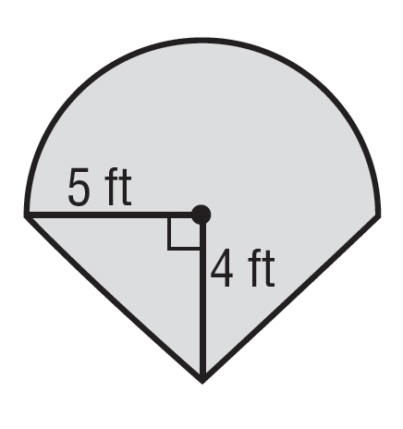
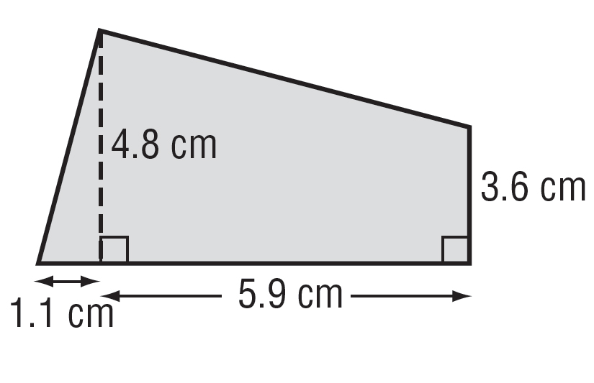
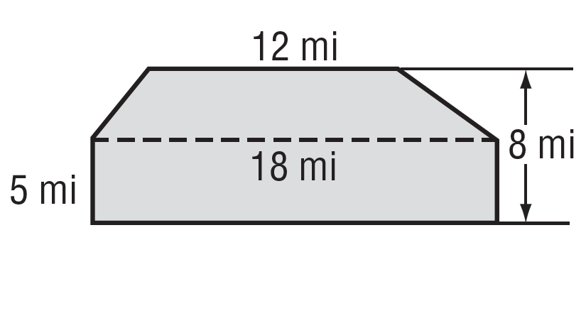

4. 5. 6.
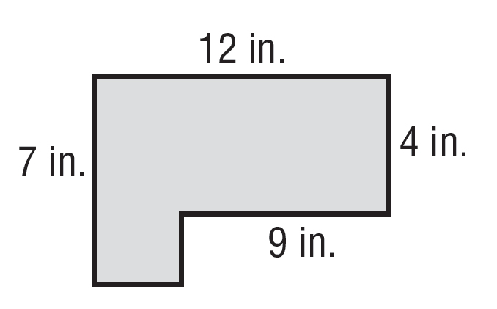
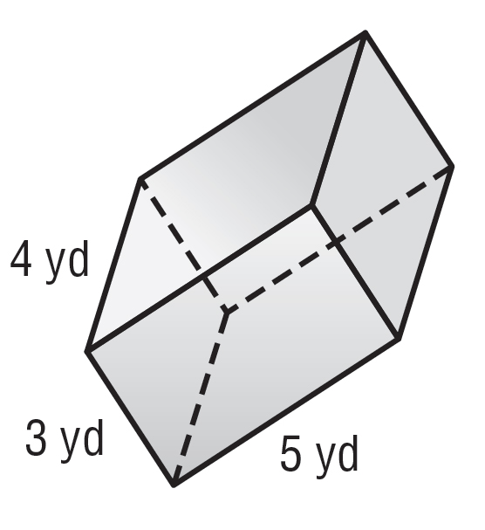
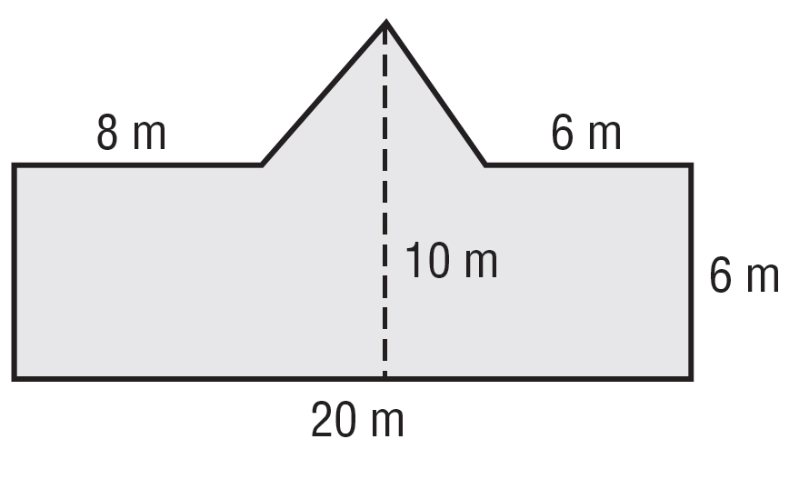

In each diagram, one square unit represents 10 square centimeters. Find the area of each figure. Round to the nearest tenth if necessary.

7. 8.
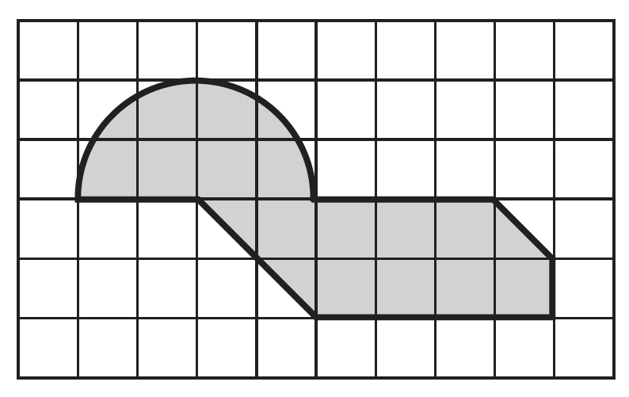
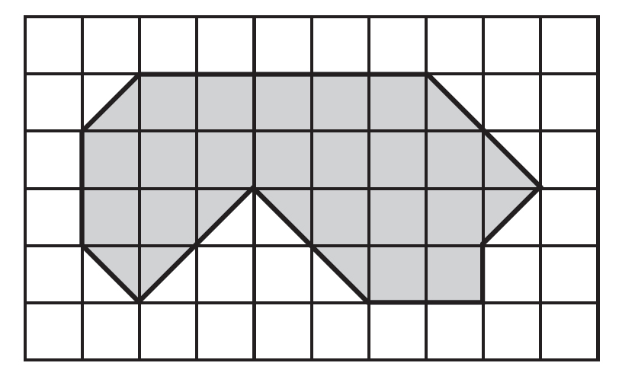

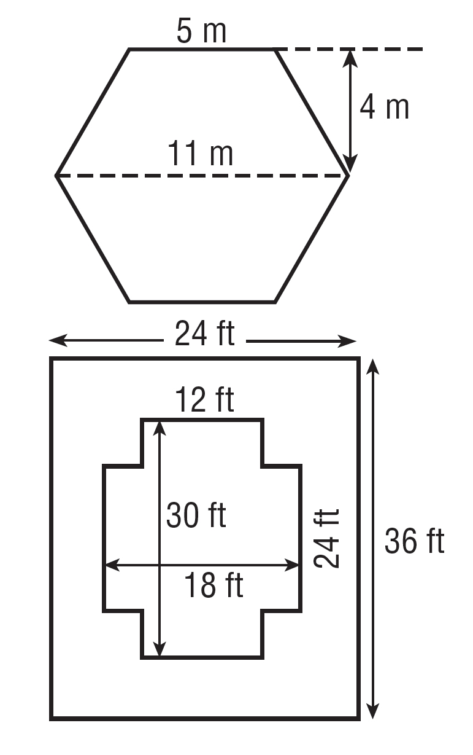

9. GAZEBO The Parks and Recreation department is building a gazebo in the local park with the dimensions shown in the figure. What is the area of the floor?

10. DECK The Pueyo family wants to paint the deck around their swimming pool with the dimensions shown in the figure. If a gallon covers 200 square feet, how many gallons of paint are needed to apply two coats of paint?

