Homework Practice

Complementary and Supplementary Angles

Classify each pair of angles as complementary, supplementary, or neither.

1. 2. 3.
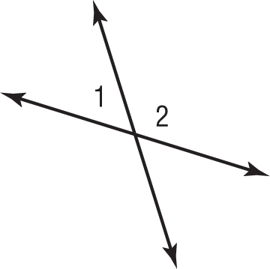
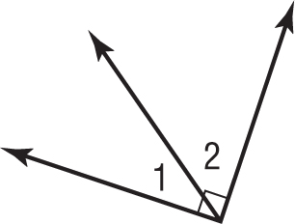
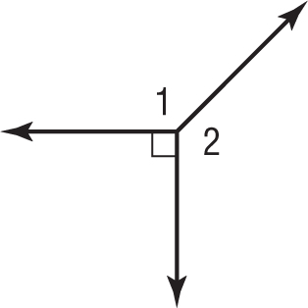

ALGEBRA Find the value of x in each figure.

4. 5. 6.

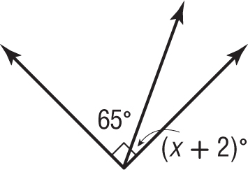
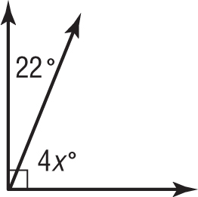
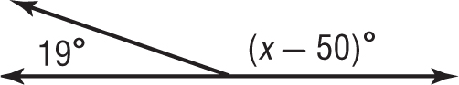

7. KITES A kite string makes an angle of 48˚ with respect to the ground as shown below. The dashed line is vertical and the ground is horizontal. How are the48˚ angle and the unknown angle related? What is the value of x?  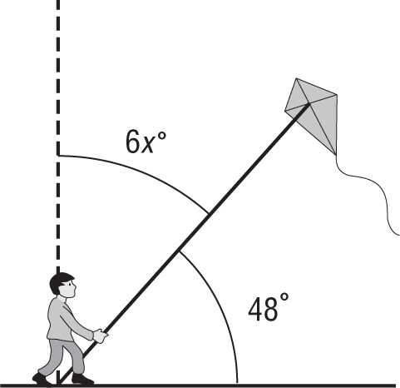 | 8. SKIING A ski jump makes an angle of 27˚ with respect to the water as shown below. How are the 27˚ angle and the unknown angle related? What is the value of x?  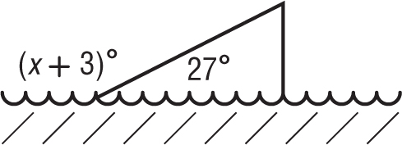 | 9. GAMES In a game of pick-up-sticks, the last 4 sticks are shown below. Which of the numbered angles are supplementary angles?  