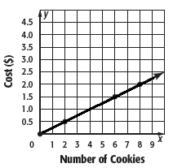

I

B

I

X

G

C

**3.**

**D.** 1, 15, 15

**C.** 10, 11, 24

**B.** 5, 11, 19

**A.** 6, 7, 21

**3.** What are three numbers that have a sum of 35 if the greatest number

is 14 more than the least number?

**H. −**

**G.**

**F.**

**I.** −

**D.**

**C.**

**A.** −

**B.** −

**2.**

**2.** What is the slope of the line that passes through the points *A*(–2, –1) and *D*(3, 5)?

**1.**

**6.** Which is the equation in slope-intercept form for the graph of the line shown?

***x***

1

***O***

1

**4.**

**I.** The cookies at store B cost more.

**H.** The cookies at store B cost $0.15 each

**G.** The cookies at store A cost $0.50 each.

**F.** The cookies at store A cost more.

**4.** The costs of cookies at store A are shown in the graph. The cost *y* for *x* cookies at store B is represented by the equation *y* = 0.30*x.* Which of the following statements is true?

***y***

**6.**

**H.** *y* = 3*x* – 2

**I.** *y* = 3*x* + 2

**5.**

**C.** slope: –7, *y*-intercept: 10

**D.** slope: –7, *y*-intercept: –10

**A.** slope: 7, *y*-intercept: 10

**B.** slope: 7, *y*-intercept: –10

**5.** What are the slope and *y*-intercept for the graph of *y* – 7*x* = 10?

**F.** *y* = –3*x* – 2

**G.** *y =* –3*x* + 2

**Course 3 •** Chapter 3 Equations in Two Variables

**Linear Function Review Worksheet**

**Write the letter for the correct answer in the blank at the right of**

**each question.**

**1.** What is the constant rate of change between *x* and *y* in the table below?

|  |  |  |  |  |
| --- | --- | --- | --- | --- |
| ***x*** | 1 | 5 | 9 | 13 |
| ***y*** | −6 | −3 | 0 | 3 |

SCORE

PERIOD

NAME DATE

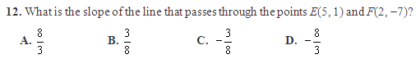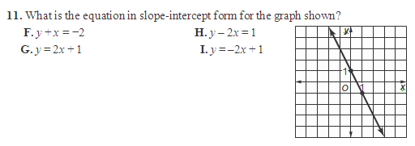

*(continued)*

**Linear Function Review**

**10.** What is the equation in slope-intercept form for the line that passes through the points (−1, 3) and (2, )?

**F.** *y* = 6*x* − 9 **H.** *y* = −6*x* − 9

**G.** *y* = 6*x* + 9 **I.** *y* = −6*x* + 9

**Course 3 •** Chapter 3 Equations in Two Variables

**12.**

**11.**

**10.**

**9.**

**9.** What is the *y*-intercept for the graph of 2*x* – 5*y* = 10?

**A.** , *y*-intercept: 10

**B.** *y*-intercept: –2/5

**C.** *y*-intercept: –2

**D.** *y*-intercept: 2

**8.** Which equation, in point–slope form, passes through (3, –1) and has a slope of 2?

**8.**

**H.** *-2x +7*

**I.** *y = 2x - 5*

**F.** *y = 2x - 7*

**G.** *y = -7x + 2*

**7.** David is having his birthday party at a water park. The park charges $150 plus $10 per guest. The total cost of the party *y* can be represented by the equation *y* = 10*x* + 150. What does the slope represent?

**A.** the number of guests

**B.** the cost to rent the water park

**7.**

**C.** the cost per guest

**D.** David’s age

PERIOD

NAME DATE

SCORE

C

F

C

G

I

A

**Linear Function Review Short Answer**



Y = 8X -12

m = 8

b = -12

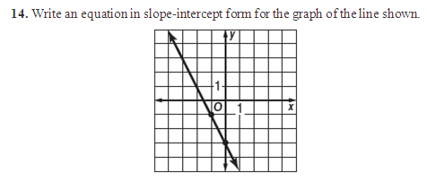

Y = -2x -2

