Homework Practice

Write Two-Step Equations

Translate each sentence into an equation. (You do not have to solve these questions)

1. Three more than eight times a number is equal to 19.

2. Twelve less than seven times a number is 16.

3. Four more than twice a number is –10.

4. Nine less than five times a number is equal to –30.

Define a variable. Then write and solve an equation to solve each problem.

5. ART Ishi bought a canvas and 8 tubes of paint for $24.95. If the canvas cost $6.95, how much did each tube of paint cost?

6. ENGINEERING The world’s two highest dams are both in Tajikistan. The Rogun dam is 35 meters taller than the Nurek dam. Together they are 635 meters tall. Find the height of the Nurek dam.

7. U.S. PRESIDENTS Use the information at the right.
President | Age at First  Inauguration
J. Carter | 52
R. Reagan | 69
G. H. W. Bush | ?
W. Clinton | 46
G. W. Bush | 54

a. If you double President Reagan’s age at the time of his first inauguration and subtract his age at the time he died, the result is 45 years. How old was President Reagan when he died?

b. If you divide the age of the first President Bush when he was inaugurated by 2 and add 14 years, you get the age of President Clinton when he was first inaugurated. How old was President G. H. W. Bush when he was inaugurated?

8. GEOMETRY Find the value of x in the triangle at the right.
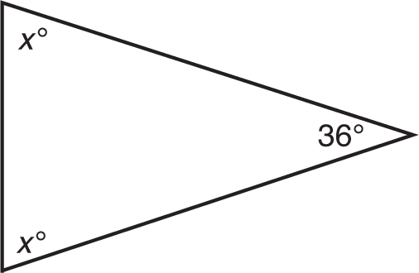

9. ALGEBRA Three consecutive integers can be represented by n, n + 1, and n + 2. If the sum of three consecutive integers is 57, what are the integers?

