Homework Practice

Translations

Draw the image of the figure after the indicated translation. Don’t forget to write the rule

1. 3 units right and 2 units up 2. 5 units right and 3 units down
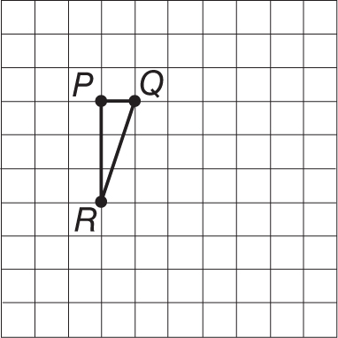
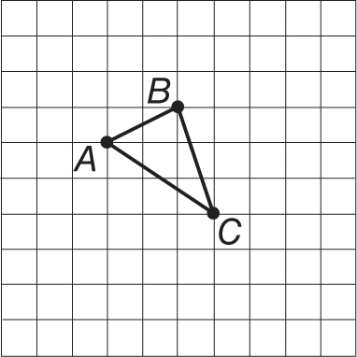

3. 2 units left and 1 unit up 4. 4 units left and 2 units down
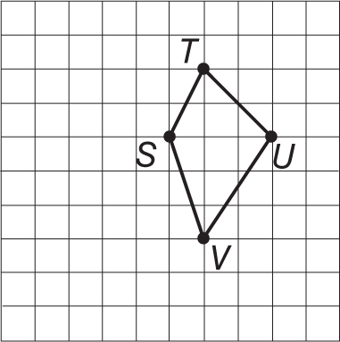
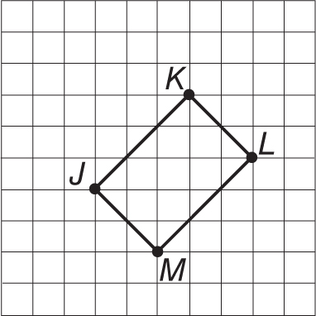

Graph the figure with the given vertices. Then graph the image of the figure after the indicated translation, and write the coordinates of its vertices. Don’t forget to write the rule

5. ∆FGH with vertices F(1, 3),
G(2, 4), and H(3, 2); translated 3 units
left and 1 unit down
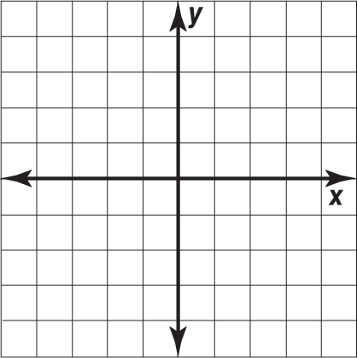
6. rectangle PQRS with vertices P(–4,–1),
Q(0, 1), R(1,–1), and S(–3,–3) translated
2 units right and 3 units up

