Subject ______________________________________ Class ________________________
Teacher _____________________________________ Date ________________________
Unit : Angle Geometry
Lesson: Parallel Lines with Algebra (Find x only)
Lesson Focus Question
How can you solve for x when angle measures are not given when parallel lines are cut by a transversal?
Standards
8.G.5: Angle relationships when parallel lines are cut by a transversal
Key concepts, content & skills
Set up an equation based on angle relationships and isolate the variable given
Learning Target;  I can | Materials  notebook
Instruction
Do Now
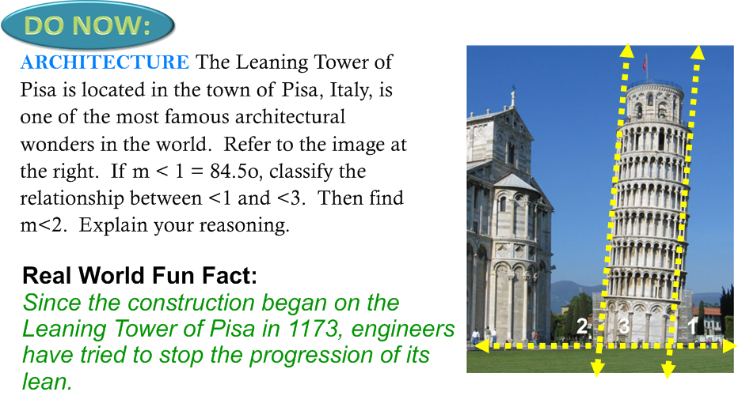
Questions:
- What kind of diagram is being represented by the leaning tower of Pisa?
- How do you know what angle 2 is?
- How do you know what angle 3 is?
- What relationships are being represented?
- How can you represent these situations using algebra?

Mini lesson: The teacher will model how to set up the problem on the board, then prompt student engagement by having students guide teacher through the algebra to solve for x

Questions:
- What relationships are being represented?
- How can you represent these situations using algebra?
- How can I solve for x?
- What properties are being used

Differentiation
Question A: Lower
Question B: On Target/Higher

Low group will work with Ms. Passarella

Guided Practice  Students will be given a multiple choice question and have to show all work to solve and explain the angle relationship they used to solve for x, then describe one distracter  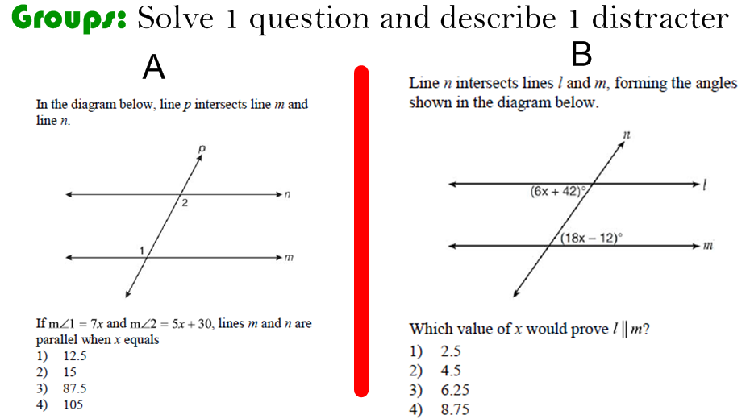 | Independent practice  Write the steps to finding x when parallel lines are cut by a transversal  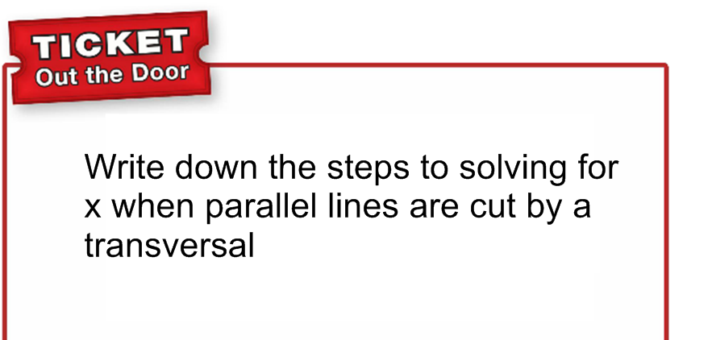
Closure/review/summary  Students will present on the smart board how they set up the problem and describe one distracter. | Assessment/ Evidence of Learning  What product or assessment will you use to let you know that students have understood the lesson objective?
Homework
Worksheet

Teacher reflections ( after lesson is delivered)
What worked well? What will you change going forward?

