Lesson 9 Homework Practice
Write Linear Equations From One Point and the Slope

PART 1:Write the equation of each line below in slope-intercept form. Show all work
PART 2: Write a real-life situation to match the equation

1. passes through (–3, 5), slope = 1/3 2. passes through (6, –6), slope = 5

3. passes through (–3, –5), slope = 2 4. passes through (-5, 6), slope = 3

Write the equation of the graphs below in slope-intercept form.
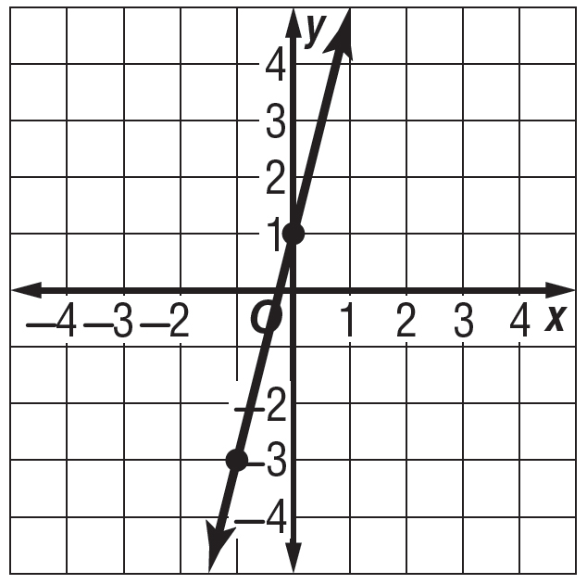
5. 6. 7. Write the # in Scientific
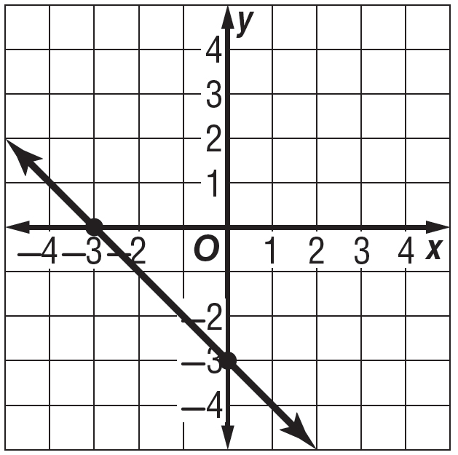
Notation

0.00000000000572

