HW 8.2d: Real-Life 2-D/3-D Pythagorean Theorem HW Practice

Write an equation that can be used to answer the question. Then solve. Round to the nearest tenth.
- How far is the wire supporting the sign?  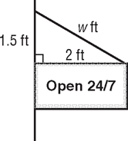 | - How far above the water is the person parasailing?  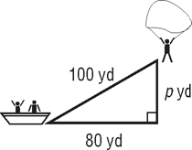 | - Find the RADIUS of the circle  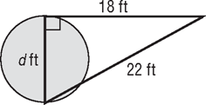
- How long is each rafter? | - How MUCH FURTHER is it to travel from Birmingham to Huntsville & make a pit stop in Gadsden, then just to travel directly to Huntsville from Birmingham?  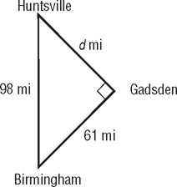
- Use the information to answer parts a + b.Kenneth wants to wrap a collapsible finish rod the box shown. 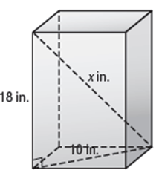w in  - In | - Find the length (x) of the fishing rod. | b.) Find the width (w) of the box,

