Lesson 8.1d: Perfect Cubes + Cube Roots Homework Practice
Evaluate the perfect cubes below
- S = 4 in  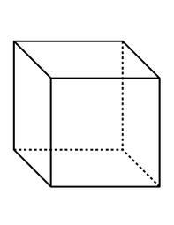 | - S = -2 units | - V = 343 in³

Solve the equations below- Show all work
- x³ = -1000 | - x³ = 729 | - ½x³ = -108
- 4x³ – 8 = 24 | - $\sqrt[3]{n+8}$ – 6 = -3 | - ${2\left(6x-3\right)}^{\frac{1}{3}}$ = 4

