Lesson 7 Homework Practice: Write Linear Equations From Graphs

Write an equation in slope-intercept form
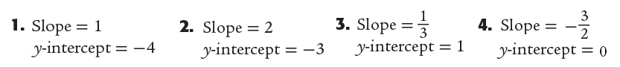
y =______________ y =_____________ y =____________ y =_____________

Question 5 | Question 6 | Question 7 | Question 8
 | 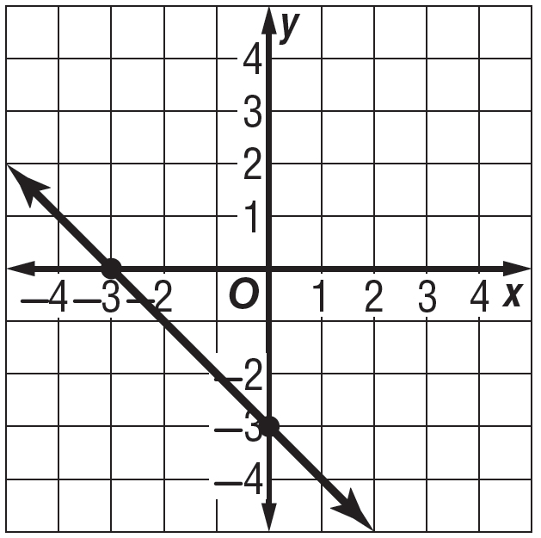
m = _____ b = _____  y =________________ | m = _____ b = _____  y =________________ | m = _____ b = _____  y =________________ | m = _____ b = _____  y =________________  **Watch Scale**

