Lesson 6 Homework Practice: Graph Lines With Out Function Tables
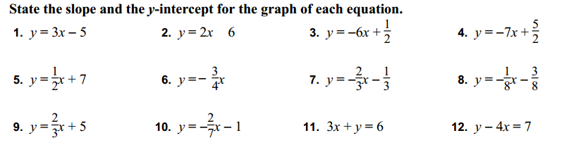
For Question 13-18, graph the linear functions without using tables
