Lesson 5 Homework: Graph Lines Using Fraction Slopes and Tables
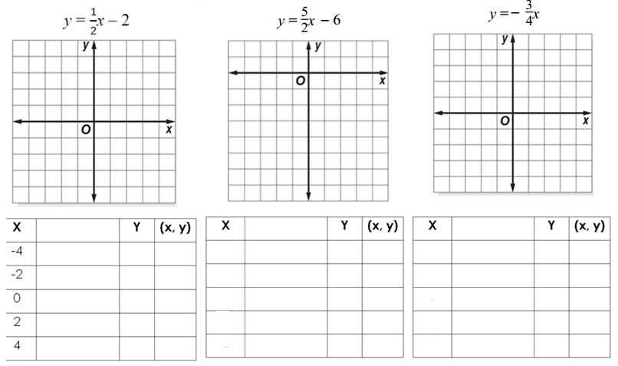
Question 4
