Lesson 4.1c_4.2c_ Construct Rotations Homework
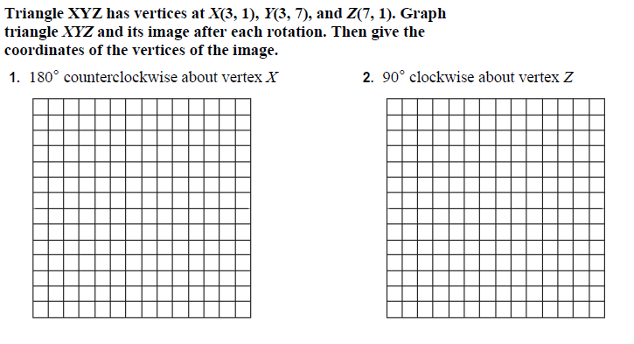
3. Triangle JKL has vertices J(-4, 4), K(-1, 3), and L(-2, 1). Graph the figure and its rotated image after a clockwise rotation of 90° about the origin. Then give the coordinates of the vertices for triangle J'K'L'.  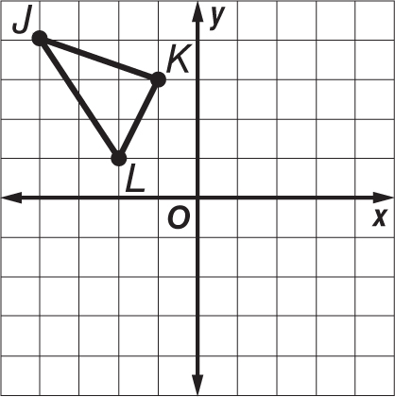 | 4. Quadrilateral BCDE has vertices B(3, 6), C(6, 5),  D(5, 2), and E(2, 3). Graph the figure and its rotated image after a counterclockwise rotation of 180° about the origin. Then give the coordinates of the vertices for quadrilateral BʹCʹDʹE'.  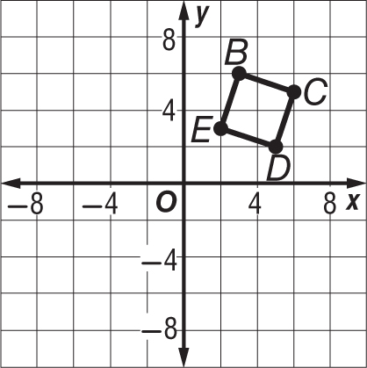

WITHOUT GRAPHING: state the coordinates for the image under the rotation given.
