Lesson 5.1b_5.2b Homework Practice: Reflections
Graph the figure and its reflection

1. Reflect triangle ABC with vertices A(–3, 4), B(1, 4), and C(3, 1) over the x-axis | 2. Reflect rectangle MNOP with vertices M(–2, –4), N(–2, –1),  O(3, –1), and  P(3, –4) over the x-axis | 3. Reflect triangle DEF with vertices D(1, 4), E(4, 3), and F(2, 0) over the y-axis | 4. Reflect trapezoid WXYZ with vertices W(–1, 3), X(–1, –4), Y(–5, –4), and Z(–3, 3) over the x-axis
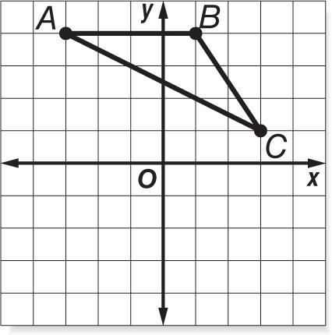 | 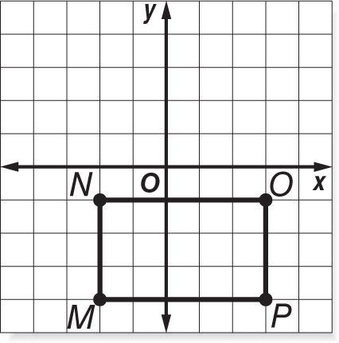 | 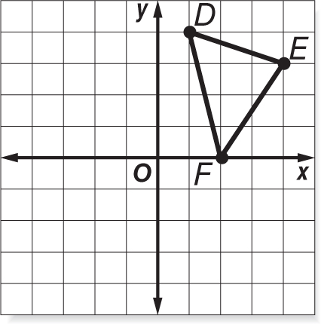 | 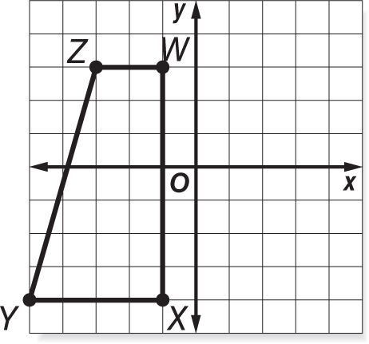

The coordinates of a point and its image after a reflection are given. Describe the reflection as over the x-axis or y-axis.
5. A(-2, 7)A’(2, 7) | 6. M(8, 9) M’(8, -9) | 7. X(-1, -4)X’(-1, 4) | 8. W(-4, 0)W’(4, 0)
Axis? | Axis? | Axis? | Axis?

