Lesson 4-7a Arithmetic Sequences – Recursive Formulas Homework
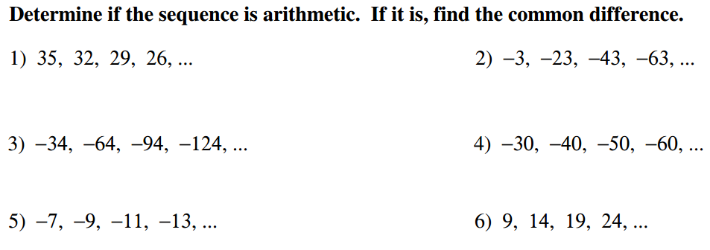

Find the recursive formula for the sequences below:
QUESTION 7 | QUESTION 8 | QUESTION 9

Find the first 5 terms in the sequence, and then write the recursive formula
QUESTION 10 | QUESTION 11 | QUESTION 12

QUESTION 13 | QUESTION 14 | QUESTION 15

TEST PREP: Multiple Choice
