Lesson 4-1a: Homework Practice: Describe and Analyze Qualitative Graphs
Describe the change in events over time
1. ROLLER COASTERS The graph below shows the speed of a roller coaster during the first 30 seconds. Describe the change in speed over time.  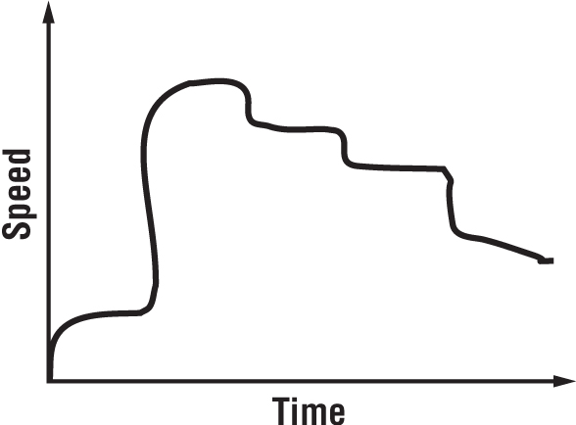 | 3. HIKING The graph below shows the altitude of a hiker during a hike. Describe the change in altitude over time.  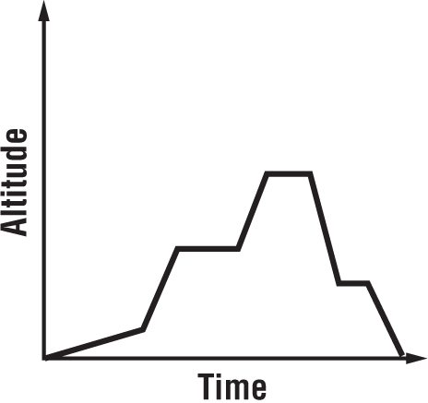
2. MONEY The graph below shows the amount of money in the Soccer Club’s account. Describe the change in balance over time.  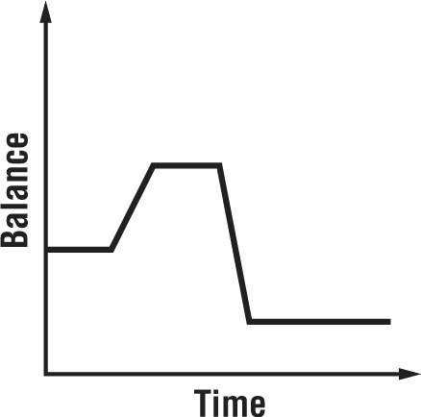  Directions: Select the correct equation for each situation. Then solve each problem. Show all work. | 4. MUSIC The graph below shows the tempo of a song as it is played. Describe the change in tempo over time  

