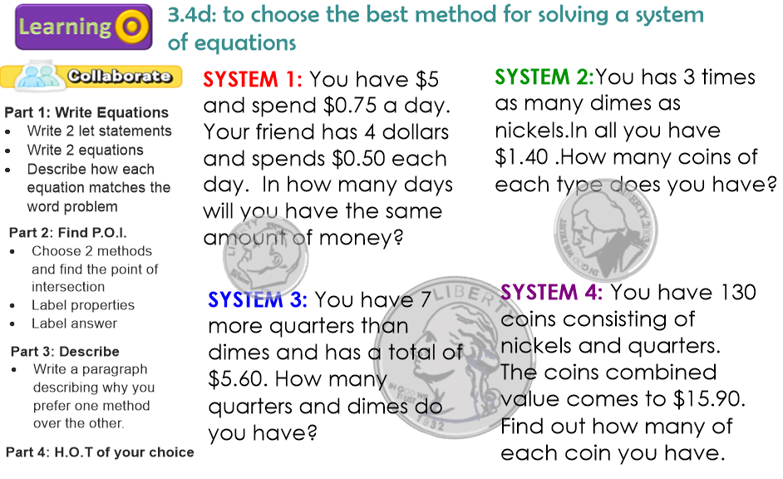
LET STATEMENTS
Let______=_______________________

Let _____ = _______________________

EQUATIONS

Equation 1:

Equation 2:

Method 1: | Method 2:
Show all work | Show all work
Which method do you prefer? Explain.

