Lesson 3.2de Homework Practice
Write Linear Equations using Algebra
PART 1:Write the equation of each line below in slope-intercept form. Show all work
PART 2: Write a real-life situation to match the equation

1. passes through (–3, 5), slope = 1/3 2. passes through (6, –6), slope = 5

3. passes through (–3, –5), slope = 2 4. passes through (-5, 6), slope = 3

5. passes through (0, 1) and (2, 5) 6. passes through (–5, 9) and (1, 3)

7. TEMPERATURE The table shows the temperature at certain hours. Assuming the temperature change is linear, write an equation in point-slope form to represent the temperature y at x hour.
Hour | Temperature  (°F)
1 | 35
2 | 39

Write the equation of the graphs below in slope-intercept form.
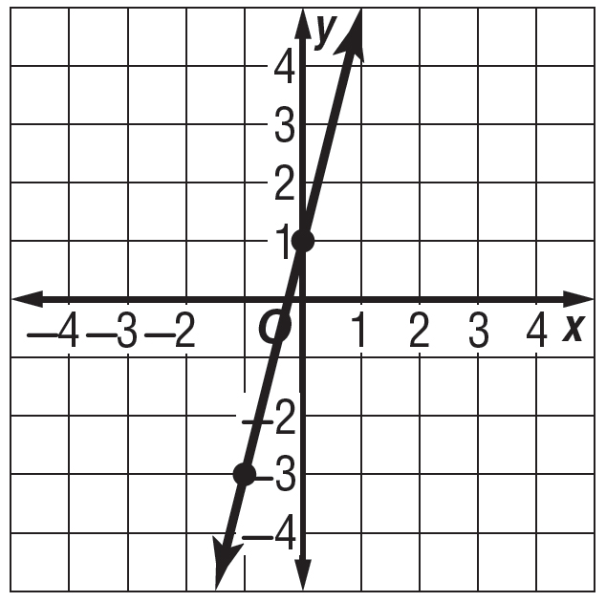
8. 9. 10. Write the # in Scientific
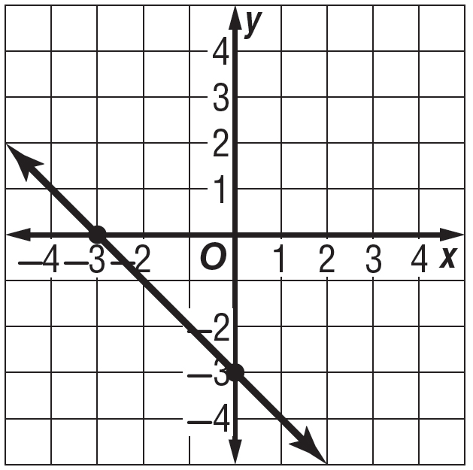
Notation

0.00000000000572

Question 11 Question 12

