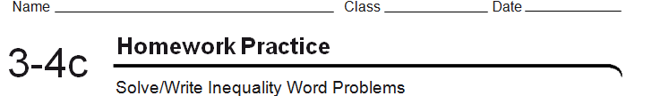
- Joe is saving for a $50 game. If his allowance is $3 per day and he already has saved $10, at least how many das will it take him to buy the game? | 2.) The perimeter of a rectangle is at most 24 cm. Two opposite sides are both 4 cm long. What are the possible lengths of the two other sides?
3.) Henry’s age is 10 years less than 4 times Paul’s age. If the sum of their ages is greater than 25 years, find the age of each boy? | 4.) 6 more than 2 times a number is less than the number increased by 20. Find the numbers that satisfy the condition.
5.) Mrs. Scott decided that she would spend no more than $120 to buy a coat and a dress. If the price of the coat was $20 more than 3 times the price of the dress, find the highest possible price for the dress. | 6.) Three consecutive integers are such that the sum of the two smaller integers is less than 32 decreased by half of the largest integer. Find the largest possible values for the integers.
7.) The student council wants to rent a ball room for the junior prom. The ballroom’s rental rate is $1500 for 3 hours and $125 for each additional half hour. Suppose the student council raises $2125. What is the maximum # of hours for which they can rent the ball room? | 8.) Challenge: The base of a triangle is 12 in. Its height is (x + 6). Its area is no more than 72 square inches. What are the possible values of x?

